Logos and Distinguishing Features

Logo | Name | Printer/Publisher
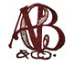 | A. C. Bosselman & Co. Print | Print
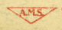 | A. M. Simon | Print
 | AAA | Publisher
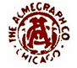 | Acmegraph Co. | Print
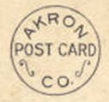 | Akron Postcard Co. | Print
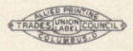 | Allied Printing | Neither! See http://www.hotcards.com/union-and-political-printing
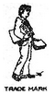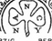 | American News Company | Print
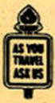 | American Oil Company | Print
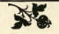 | American Printing and Supply Co. | Print
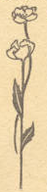 | Art Manufacturing Co. | Print
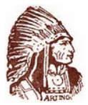 | Artino Post Card Co. | Print
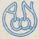 | Atkinson News Co. | Print
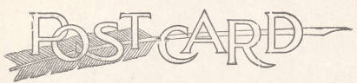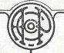 | Auburn Post Card Manufacturing Co. | Print
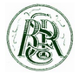 | B. S. Reynolds Co. | Publisher
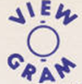 | Bartone | Print
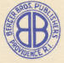 | Berger Bros. | Publisher
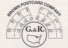 | Brown Postcard Co. | Publisher
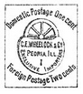 | C. E. Wheelock and Co. | Print
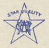 | C. W. Hughes & Co. | Publisher
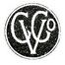 | Cardinell-Vincent Co. | Print
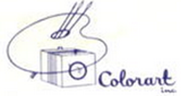 | Colorart Inc. | Print
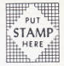 | Colourpicture Pub. | Printer
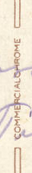 | Commercial Colortype Co. | Print
 | Consolidated Art Co. | Print
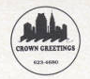 | Crown Greetings | Publisher
 | Curt Teich & Co. | Print
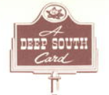 | Deep South Specialties | Publisher
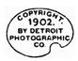 | Detroit Publishing Co. | Print
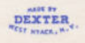 | Dexter Press | Print
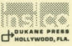 | Dukane Press | Print
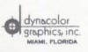 | Dynacolor Graphics | Print
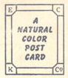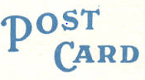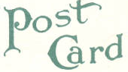 | E. C. Kropp Co. | Print
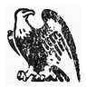 | Eagle Post Card View Co. | Print
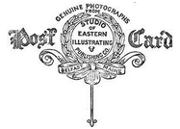 | Eastern Illustrating Co. | Print or Publisher
 | Forward’s Photo Studio | Publisher
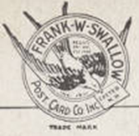 | Frank W. Swallow Post Card Co. | Print
 | Frasher’s Inc. | Publisher
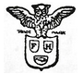 | Franz Huld | Print
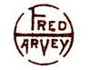 | Fred Harvey | Publisher
 | F. W. Woolworth Co. | Publisher
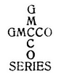 | Green Mountain Card Co. | Publisher
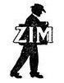 | H. G. Zimmerman & Co. | Print
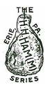 | H. H. Hamm | Print
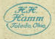 | H. H. Hamm | Publisher
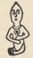 | H. H. Tammen Curio Co. | Print
 | H. K. Barnett | Printer
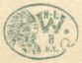 | H. L. Woehler | Print
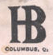 | Haenlien Bros. | Publisher
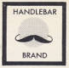 | Handlebar Brand | Publisher
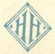 | Harold Hahn | Publisher
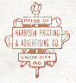 | Harrison Printing & Advertising Co. | Print
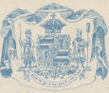 | Hawaii and South Seas Curio Co. | Print
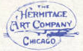 | Hermitage Art Co. | Publisher
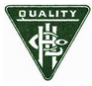 | Hugh C. Leighton Co. | Print
 | I. & M. Ottenheimer | Publisher
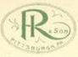 | I. Robbins and Son | Publisher
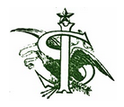 | Ignatz Stern | Print
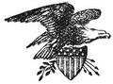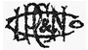 | Illustrated Post Card Co. | Print or Publisher (see printer list)
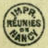 | Imprimeries Réunies de Nancy | Print
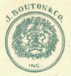 | J. Bouton & Co., Inc. | Print
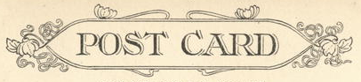 | J. Murray Jordan | Print
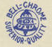 | J. P. Bell Co. | Publisher
 | Jenkins Enterprises | Print
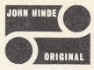 | John Hinde Limited | Print
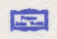 | John Webb | Print
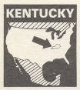 | Kentucky Souvenir Sales | Publisher
 | Kolorview Press | Print
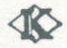 | Koppel Color Cards | Print
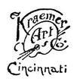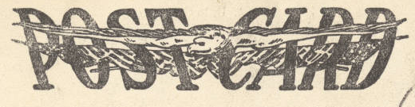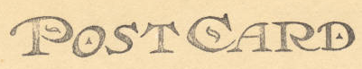 | Kraemer Art Co. | Print
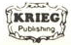 | Krieg Publishing Co. | Publisher
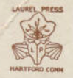 | Laurel Press | Print
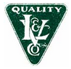 | Leighton & Valentine Co. | Print
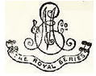 | Max Ettlinger & Co. | Print
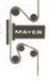 | Mayer Photo-graphics | Publisher
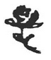 | Mayrose Co. | Print
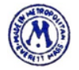 | Metrocraft | Print
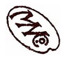 | Metropolitan News Co. | Publisher
 | Midwest Map Co. | Print
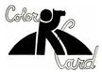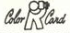 | Mike Roberts | Print or Publisher (see printer list)
 | Miller Art Co. | Publisher
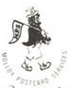 | Molloy Postcard & Souvenir Services | Publisher
 | MWM Dexter | Print
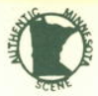 | Northern Minnesota Novelties | Publisher
 | Northwest Orient Airlines Photo | Print
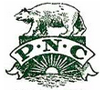 | Pacific Novelty Co. | Print
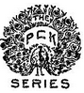 | Paul C. Koeber Co. | Print
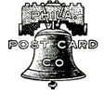 | Philadelphia Post Card Co. | Print
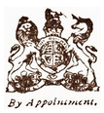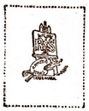 | Raphael Tuck & Sons | Print
 | Robbins Bros Co. | Print
 | Rotograph Co. | Print
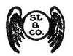 | Samuel Langdorf & Co. | Print
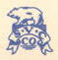 | Scenic View Card Co. | Publisher
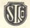 | Security Lithograph Co. | Print
 | Souvenir Post Card Co. | Print
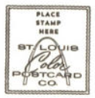 | St. Louis Color Postcard Co. | Print
 | Standard Oil | Publisher
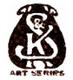 | Suhling & Koehn Co. | Print
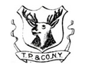 | Taylor, Platt & Co. | Print
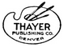 | Thayer Publishing Co. | Print
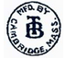  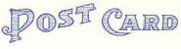 | Tichnor Bros. | Print
 | Union News Co. | Publisher
 | Valentine & Sons Publishing Co. | Print
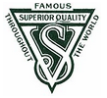 | Valentine-Souvenir Co. | Print
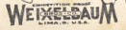  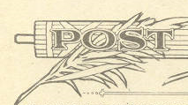 | Weixelbaum | Print or Publisher (see printer list)
 | Wesley Andrews Co. | Publisher
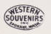 | Western Publishing and Novelty Co. | Publisher
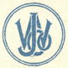 | Wm. Jubb Co. | Publisher

*Teich vs. Ticnor (respectively)
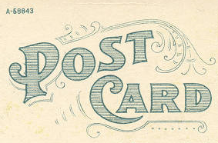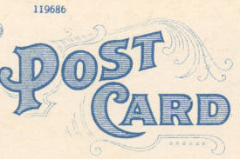
1. The bottom curl under “D” is tighter in Teich.
2. The curl next to the “T” is larger is Teich.
3. The third curl away from the “T” (over the “R”) is pointed in Tichnor, but curly in Teich.
4. The )) above the “D” and “O” are longer in Teich.
5. Teich has a curl between “P” and “O”
6. The serial numbers.
7. There are seven dots under the word “Card” in Teich, but only 5 in Tichnor.
8. The curl under the “C” is curlier in Tichnor.

Unknown Postcard Logos and Distinguishing Features

Logo | Description | Postcards
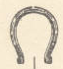 | A black horseshoe above the center line of the postcard. | B-OH-ATH1-16
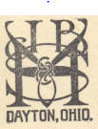 | JB&SHV? VHS&JB? JB&KH?  All I know for certain is the Dayton, Ohio part. | B-OH-BAT1-1
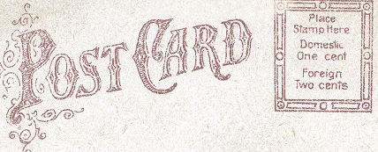 | Technically not a logo, but it’s distinguishable and I’ve seen it before. On many  S.H. Knox cards. | B-OH-CED3-68  B-OH-CED3-85  B-OH-CAM1-19  B-OH-CAM1-25  B-OH-CAM1-28  B-OH-CAN5-50  B-OH-CAN5-81  B-OH-MCC-113  B-OH-HAM2-275  B-OH-HAM2-290  B-OH-HAM2-333-337  B-OH-HAM2-370-373  B-OH-HAM2-542-544
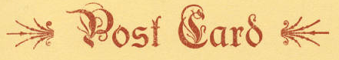 | While also not really a logo…. Sometimes it doesn’t have the images on the sides, just the text. | B. S. Stapleton (publisher) postcards and  B-OH-DOV1-6  B-OH-CAN5-100
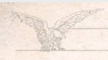 | Two eagles, facing eachother with the “Post Card” in between. | There’s a million. Norwood Souvenir uses this printer, as well as Cott Printing and Fiecke-Desch.  Also found on:  B-OH-OXF1-121  B-OH-OXF1-183
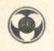 | Top left hand corner of the back. | Possibly a Haenlien Bros. logo. Found on a few of their postcards.
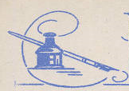 | Found next to “Post Card” | B-CT-BER1-2
 | Found in bottom left corner | B-OH-OXF1-79

