Beginner’s Guide to Postcards

Table of Contents
Uploading Postcards into ContentDM 2
General Steps 2
Steps Without Images 12
Pro Tips and Shortcuts 12
Editing Metadata in ContentDM 13
Getting Started 13
Quick Starting Steps 23
Pro Tips and Shortcuts 24
Metadata Tips by Field 24
Useful Websites 29
Using and Editing the Postcard Guides 30
Common Problems 33

Uploading Postcards into ContentDM

General Steps
1) Find the physical copy of the postcard(s) you want to upload. I’ll be demonstrating the process with B-OH-JAC1-1 through 5. Be sure to have them within reach.
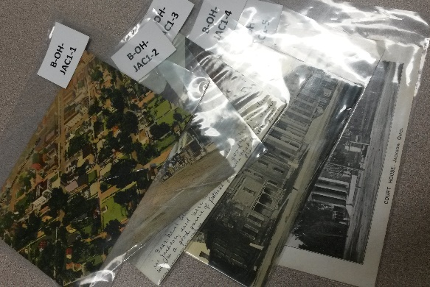

2) Locate the digital copy of the postcard(s). The directory for all previously scanned postcards is \\libstore2\Production\Postcards. It looks like this:
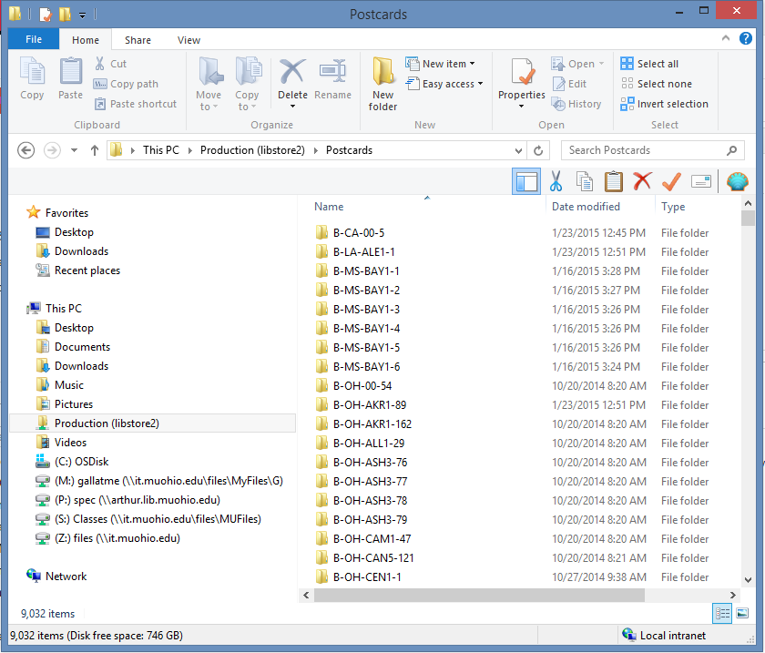

The name of the card’s folder should be the same as the card number on the top right corner of the postcard (So mine is B-OH-JAC1-1, making the total directory \\libstore2\Production\Postcards\B-OH-JAC1-1 ) If you can’t find the digital copy of a postcard, see the Common Problems section (1).
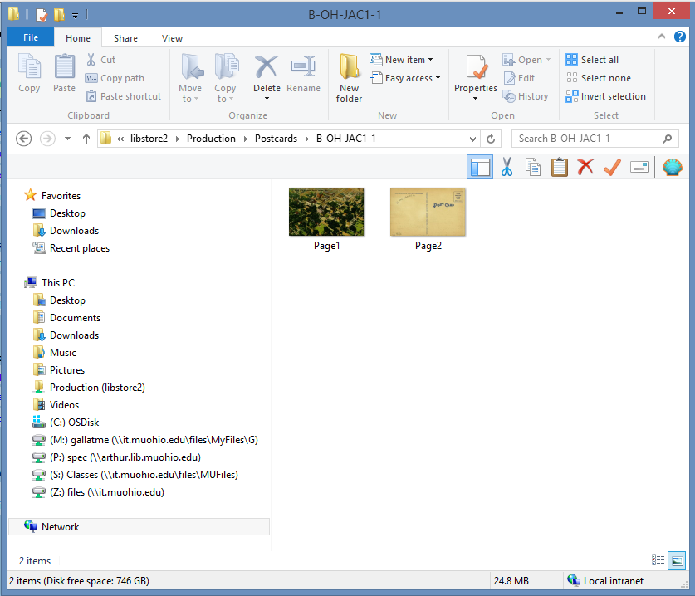

3) Copy the directory name for the first postcard in your series of postcards. This will be useful in a few steps. As previously stated, the name for mine is \\libstore2\Production\Postcards\B-OH-JAC1-1.
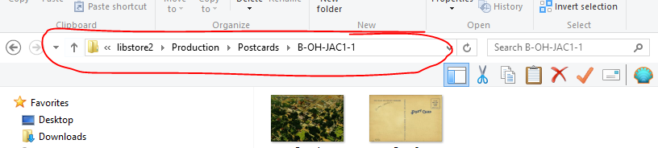

4) Open ContentDM, if you haven’t already. It should look something like this:
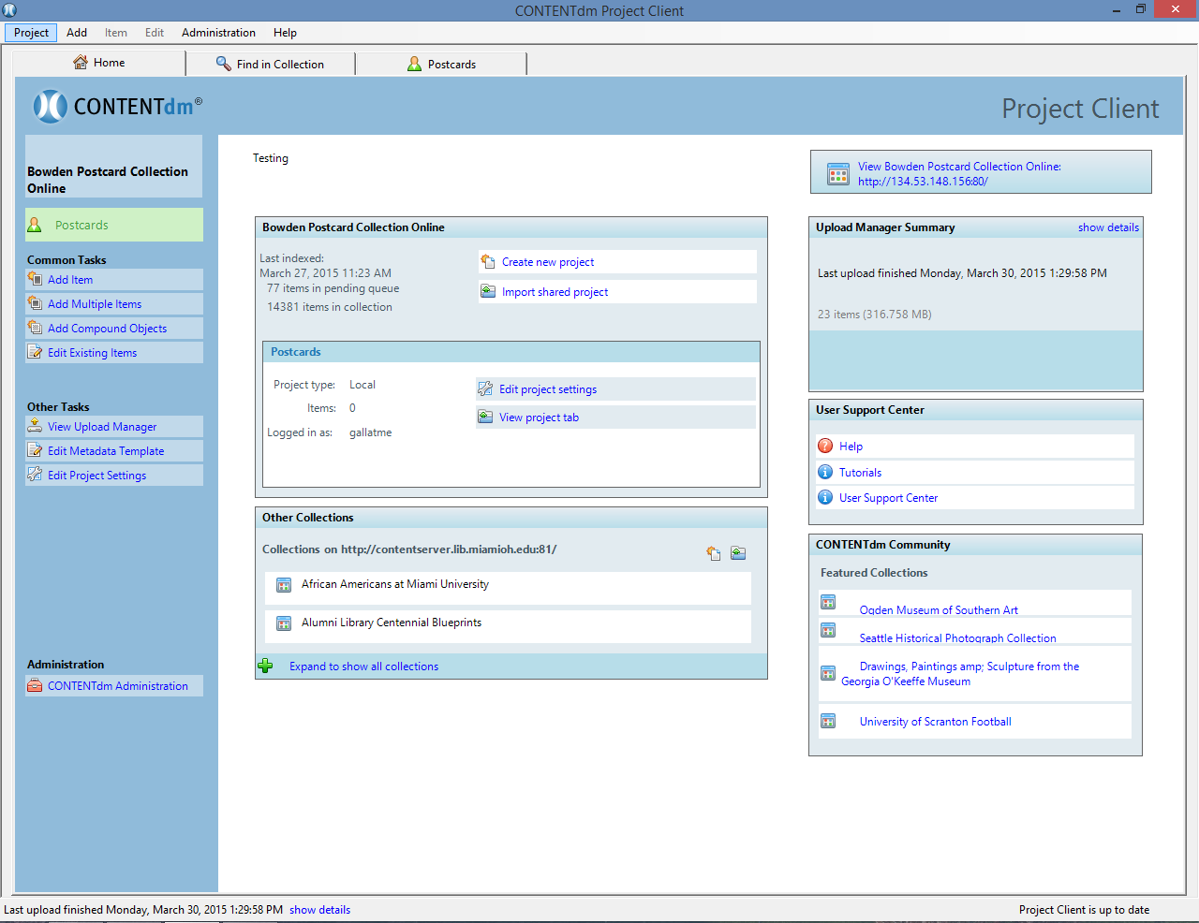

5) Click “Add Compound Objects” on the left side.
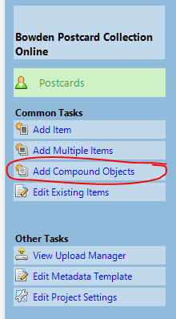
6) This dialogue box will open. Click on “Add.”
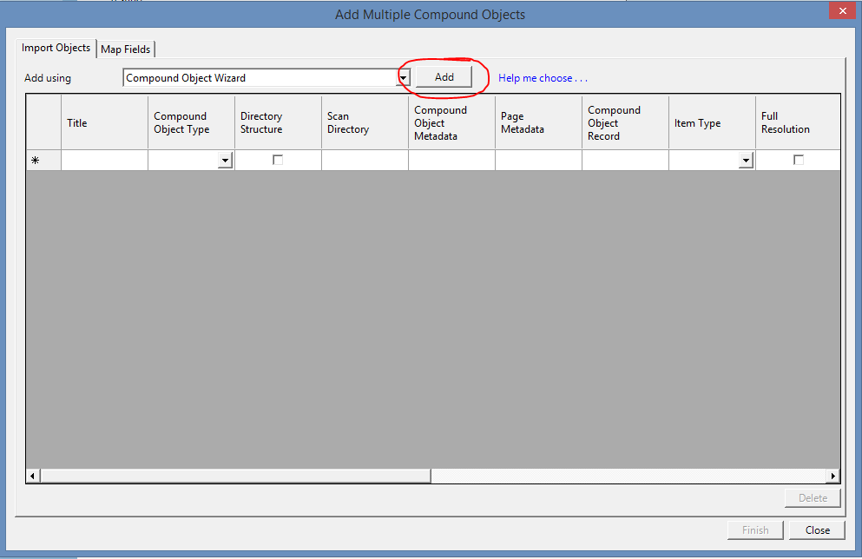

7) Another dialogue box will open. Make sure the radio button that says “Postcard” is selected, then click “Next.” If your postcard has more than two sides or images, see the Common Problems section (2).
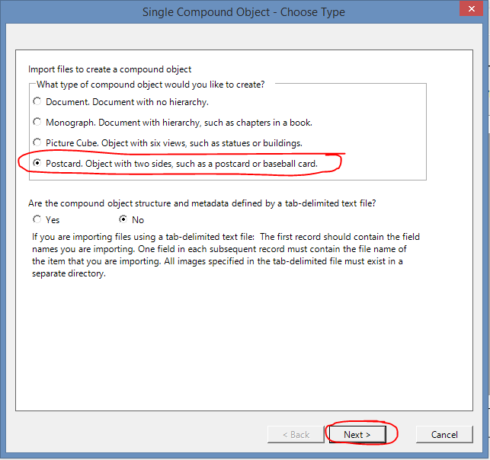
8) This is where you should type or paste the directory name. The directory for the last added postcard will automatically fill in the directory name. After you check that the directory name is correct, click “Next.”
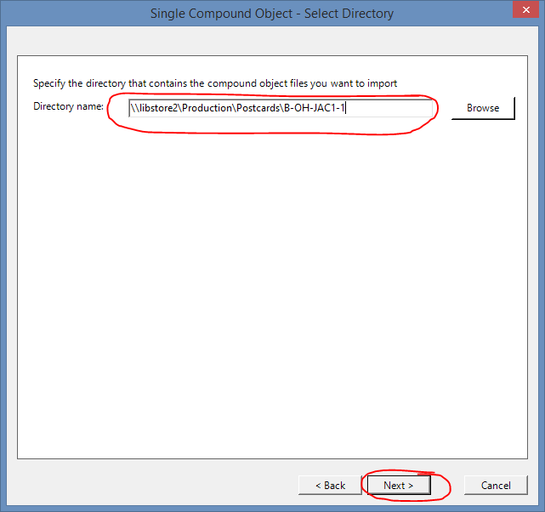

9) The settings for the next two boxes do not change, so click “Next” when these pop up. I will show the standard settings for each as a reference.
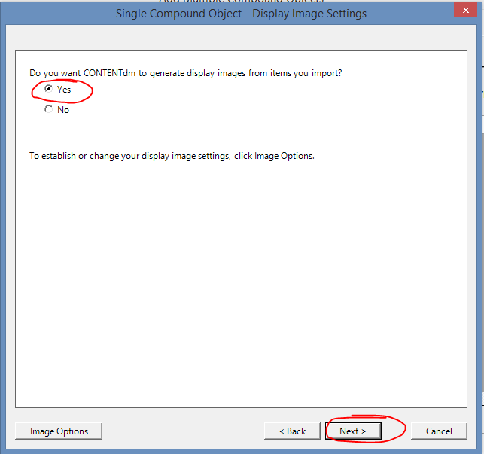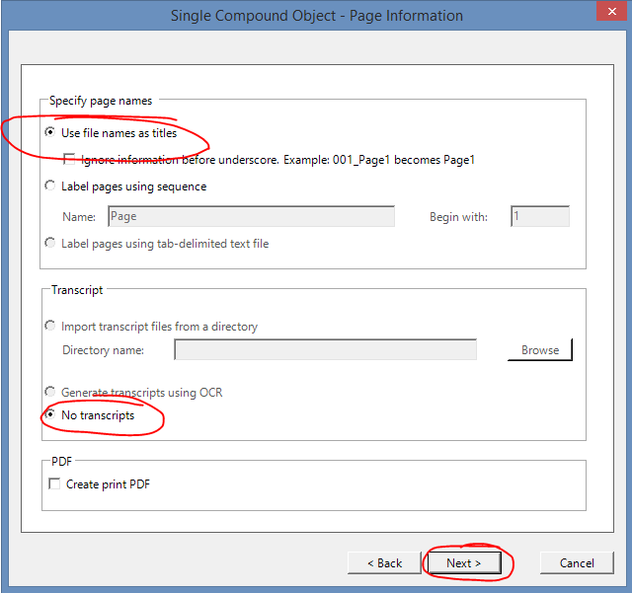

10) A dialogue box with the settings you’ve selected will appear. Click “Finish.”
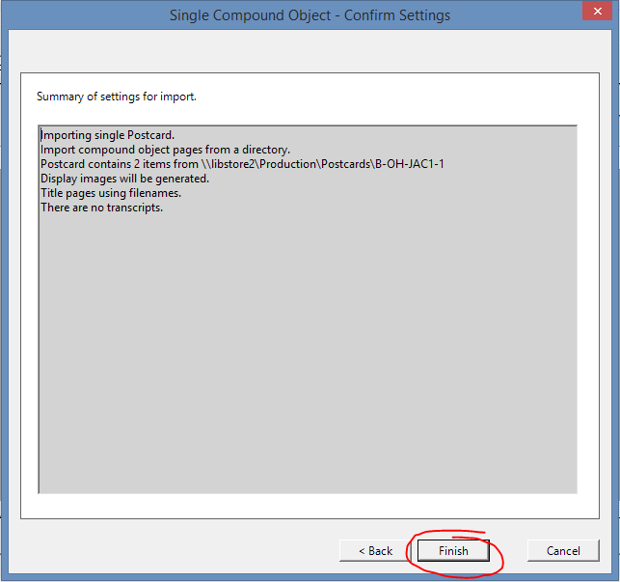

11) This will show up. Be sure it says “2 pages.” Click “Close.”
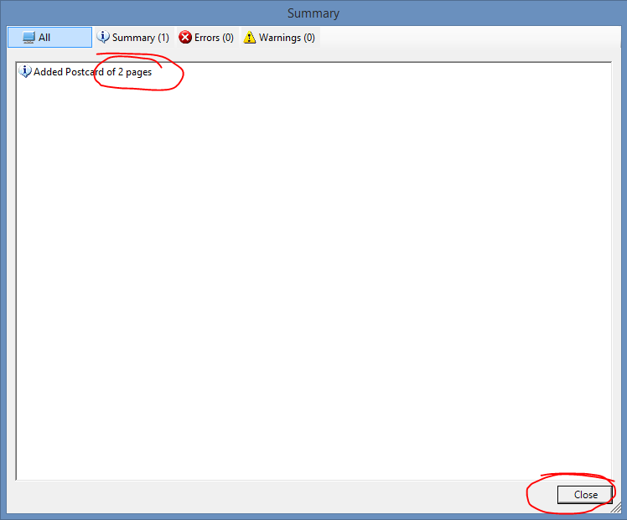
12) The first dialogue box will now show the postcard you just added and look something like this:
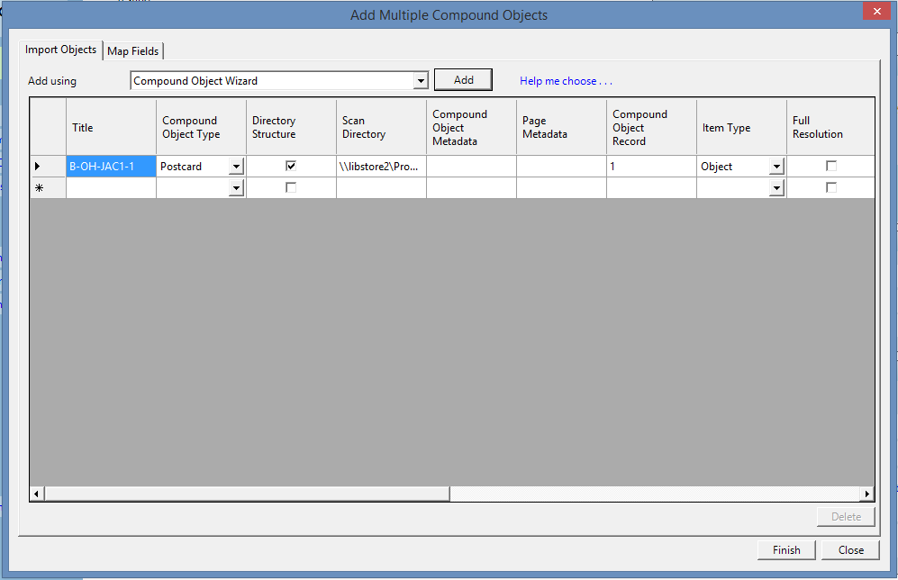

13) If this was your only postcard, skip the next step. To add another postcard (I’ll be adding B-OH-JAC1-2 through 5 now), click “Add” again.
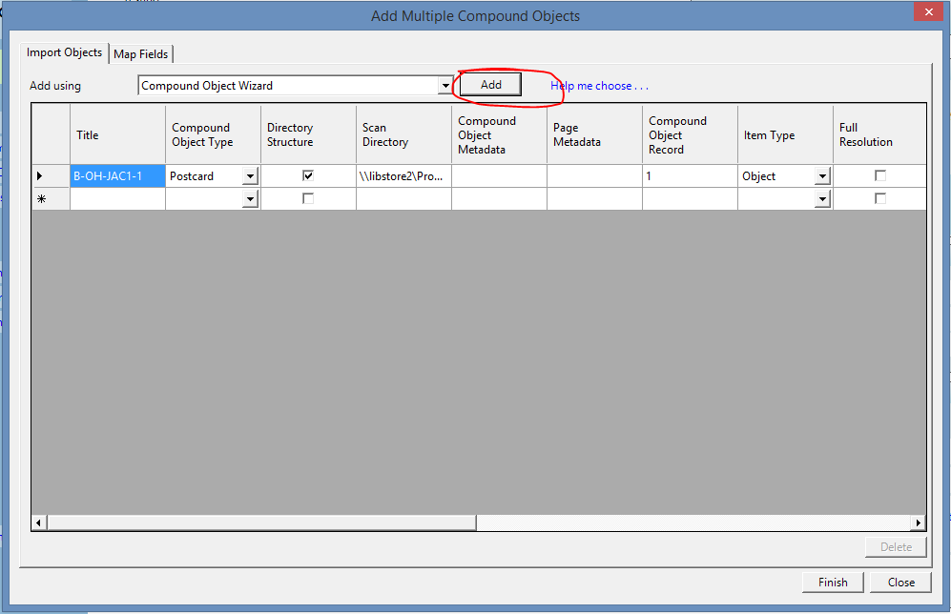
14) Steps 7 through 11 are essentially repeated here, but instead of copying the directory name from the digital file, you can just type the new card number. For example, I clicked on the dialogue box, pressed backspace, and typed “2” where there was previously “1.” Repeat as needed.
15) When you have added all your postcards (I’ve added 5), double check that the “Compound Object Type” says “Postcard” for all of them (with the exception of several-page postcards-see Common Problems section) and that you haven’t skipped any postcards or added a postcard twice. If you did add a postcard twice, see the Common Problems section (3). Click “Finish.”
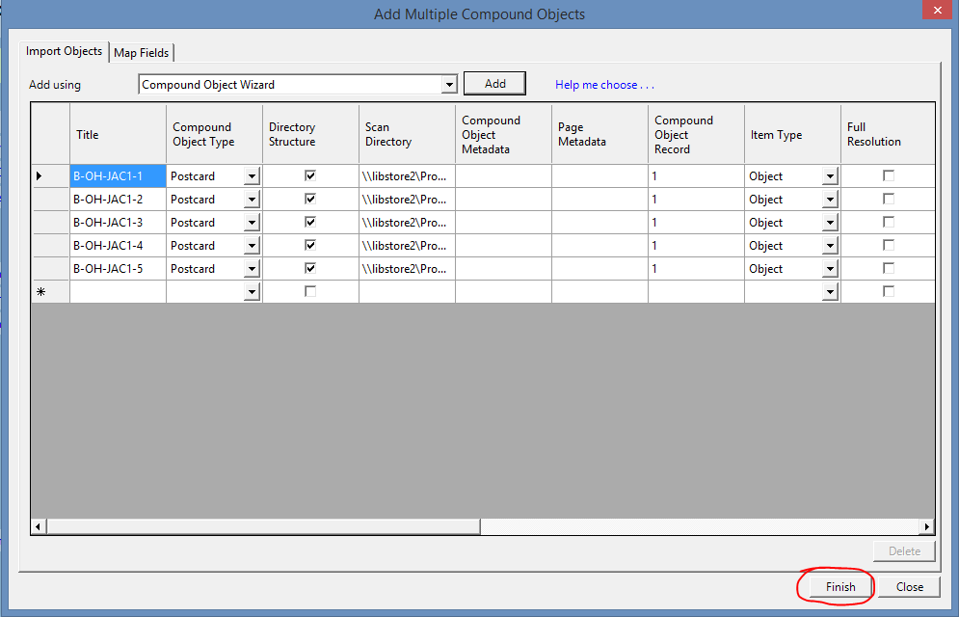

You will see the progress of your postcards in a new pop-up as they are added to ContentDM.
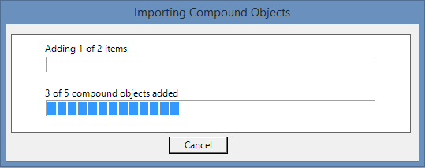

16) When this dialogue box appears, click “Close.”
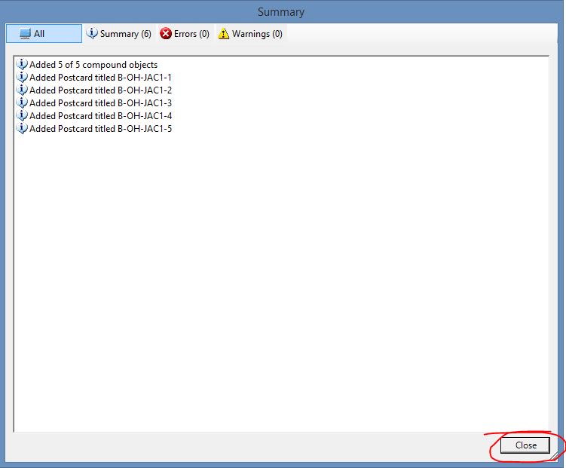

17) This screen will appear. You can now move on to editing the metadata for these postcards.
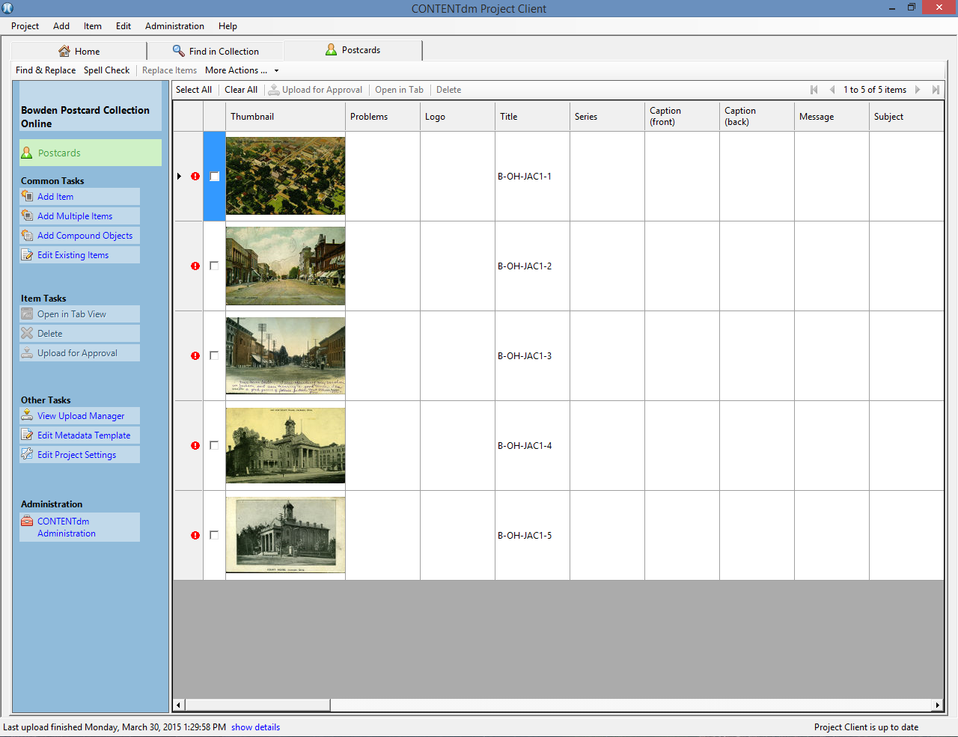

Steps Without Images
1) Have the physical copies of the postcards desired for uploading.
2) Located the digital copy of the postcards. Postcards that have already been scanned are found in the directory (folders) \\libstore2\Production\Postcards. If your postcard is not found here, see Common Problems (1).
3) Copy the directory name for the first of the postcards you’ll be uploading.
4) Open ContentDM.
5) Click “Add Compound Objects” on the left side.
6) Click “Add” when the dialogue box appears.
7) In the new dialogue box, make sure the radio button that says “Postcard” is selected, then click “Next.” If your postcard has more than two sides or images, see the Common Problems section (2).
8) Paste the directory name in the box, then click “Next.”
9) Click “Next” for the next two boxes.
10) Click “Finish.”
11) Check that the dialogue box says “2 pages.” Click “Close.”
12) The first dialogue box will now show the postcard you just added.
13) If this was your only postcard, skip the next step. To add another postcard, click “Add” again.
14) Steps 7 through 11 are essentially repeated here, but instead of copying the directory name from the digital file, you can just type the new card number. Repeat for each postcard.
15) When you have added all your postcards, double check that the “Compound Object Type” says “Postcard” for all of them (with the exception of several-page postcards-see Common Problems section) and that you haven’t skipped any postcards or added a postcard twice. If you did add a postcard twice, see the Common Problems section (3). Click “Finish.” Upload progress will be shown.
16) When a new dialogue box appears, click “Close.”
17) When the images and metadata editing area appears, you can move on to editing metadata.

Pro Tips and Shortcuts
- There are exactly seven clicks from one step 8 to the next. When adding multiple normal postcards, you can press enter seven times to smoothly transition from one postcard to the next.
- There is no need to retype the postcard directory name for each postcard. When going quickly (the “press enter” method) press the right arrow on the keyboard, then backspace, then type the next postcard number.
- ContentDM works best with small numbers of postcards. I don’t recommend uploading more than 50 at a time. I usually do about 20, but try to keep all the postcards from one town together – it makes finding locations easier.
- The collector Bowden (the “B” in the card number) organized his collections by location, then by an unlabeled subcategory. There is a specific order the subcategories (Aerial photographs, Street scenes, Court houses, Post offices, Schools, so on and so forth) which can be used when selecting postcards to upload. The other main collector, Shields (indicated with an “S”) did not do this.

Editing Metadata in ContentDM

Getting Started
Disclaimer: This is how I do things, not at the only way and not necessarily the “correct” way. Marcus has final say on all postcards and postcard editing methods.
1) Open ContentDM and click the “Postcards” or “New Postcards” tab (it may be named something else, but will always be the third tab. I have circled it in red). A screen like this should appear, with all your previously uploaded postcards in it and any changes to the metadata you may have made.
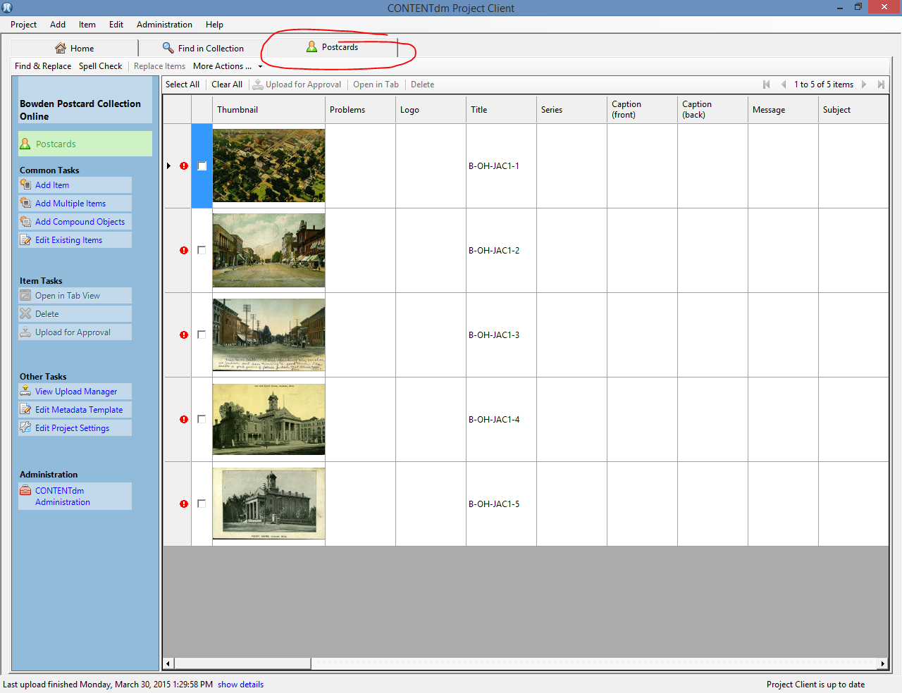

2) The very first thing I do when editing metadata is to copy the Card Number from the title field (it’s automatically put there) and paste it into the “Card No.” field. To make this easier, collapse all the fields in between “Title” and “Card No.” This is done by hovering the mouse over the dividing lines for each category at the top until a double arrow appears and then right-clicking and dragging.
This area:
One collapsed box:
When all are collapsed (this is what I want you to do):
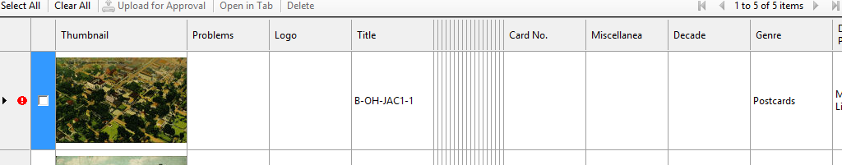
To copy, click on the title field of the postcard you want to copy to highlight it blue:
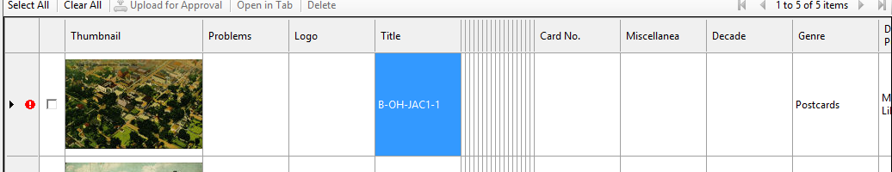
On your keyboard, press CTRL+C to copy, then click on the Card No. field of the same postcard to highlight it blue:
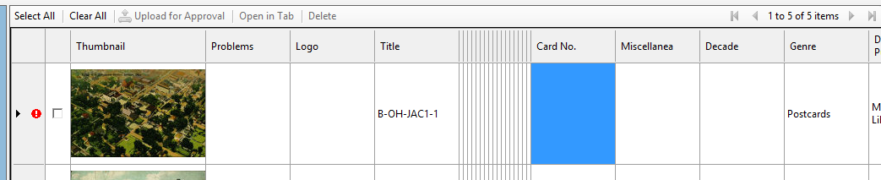

Press CTRL+V to paste the card number into the Card No. field. Repeat for all postcards.
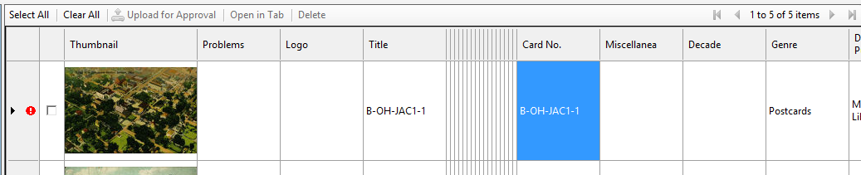

When finished, your screen should look like this:
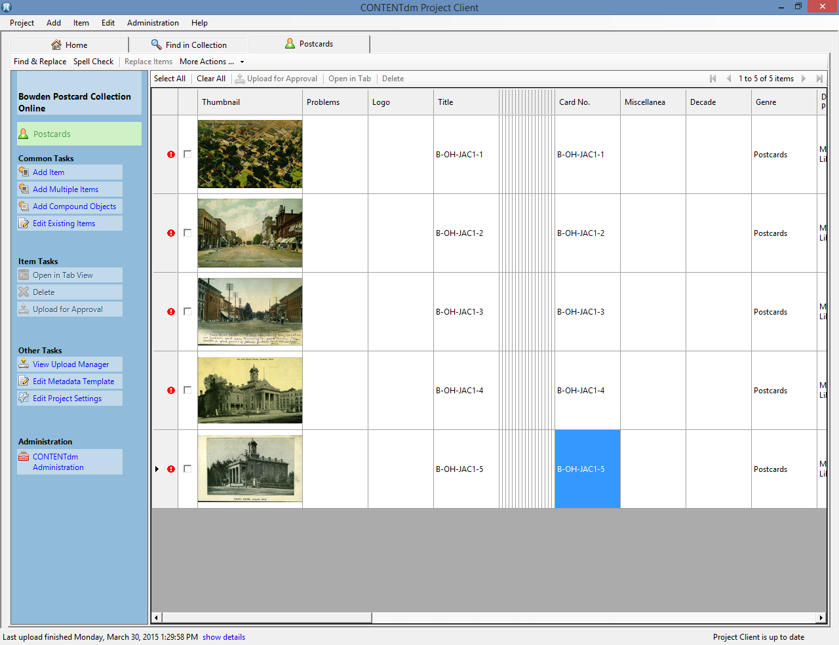

3) Because of the way ContentDM is programmed, it’s much quicker and easier to exit the program and re-open it rather than try to uncollapse each of the boxes. Do this. When ContentDM re-opens, double check to make sure the card numbers are correct.

4) Scroll over to the “Location” Field. If all your postcards are from the same location, type that location (in the format “State--Town;” if you are unsure about the location, see Common Problems (4) or the Metadata Guidelines in Google Drive, page 4) then click on another box, right-click on the location box, and select “Fill Down” or “Fill All.”
This is the location field:
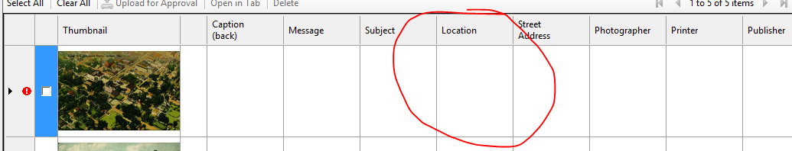
Type in the location (these postcards of Jackson, Ohio, which makes the location Ohio--Jackson)
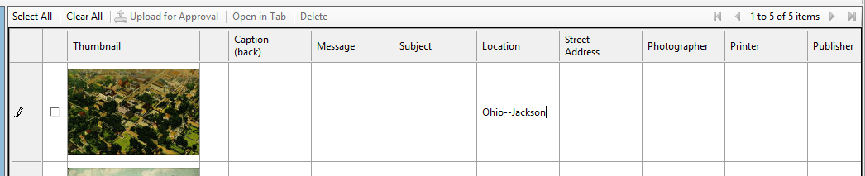
Click on another box (it doesn’t matter which)
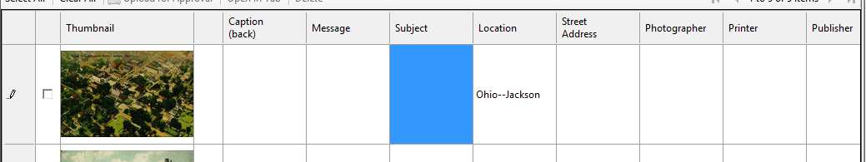
Right-click the location box and select “Fill Down” or “Fill All” to quickly fill the location field of every postcard.
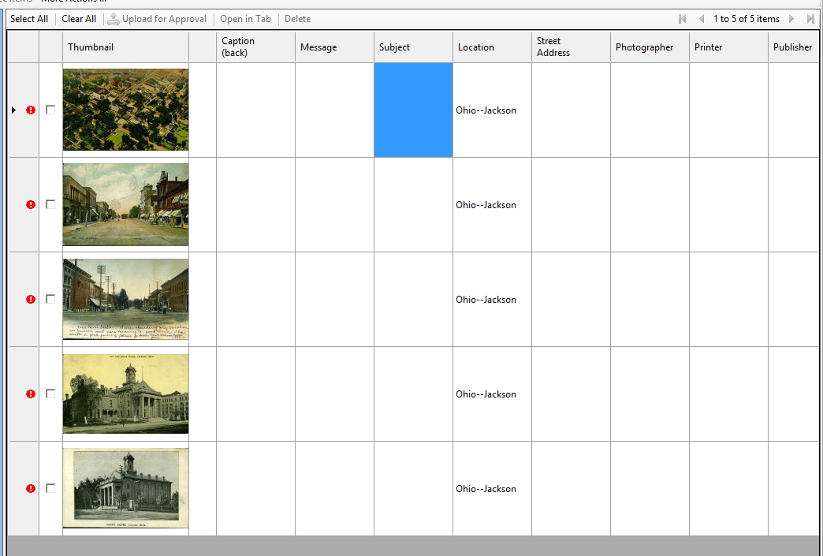
If the postcards are from multiple locations, it is better just to type each individual location, and copy and paste from box to box as needed.
5) Scroll to the “Postage.” Using the same method as for Step 4, fill all the postcards with the word “No.” It is much more common to have postcards with no postage. This can be changed on a postcard-to-postcard basis.
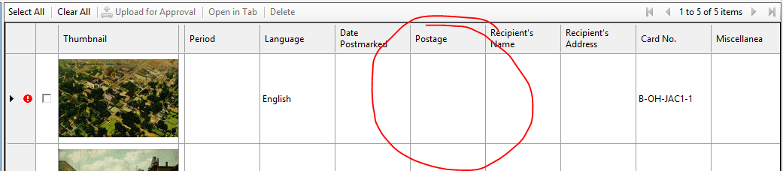
Afterwards, it should look like this:
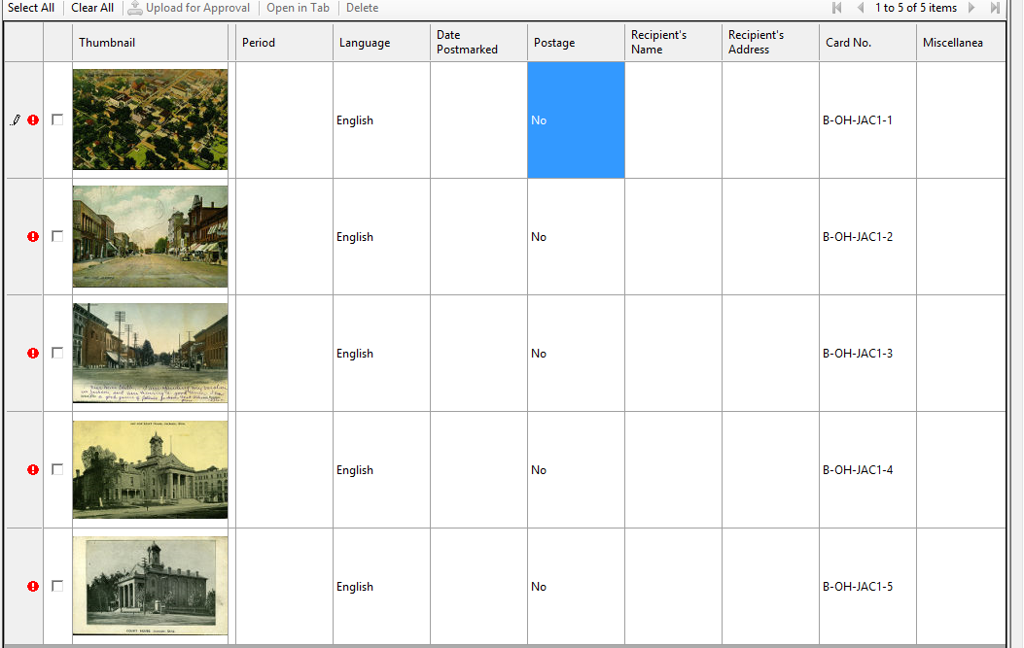

6) Scroll to the “Digital Production” field. This is the date you added the postcards into ContentDM, in the format YYYY-MM-DD (So for my postcards, it is 2015-03-31). Use the method from Step 4 to fill all the boxes in this field.
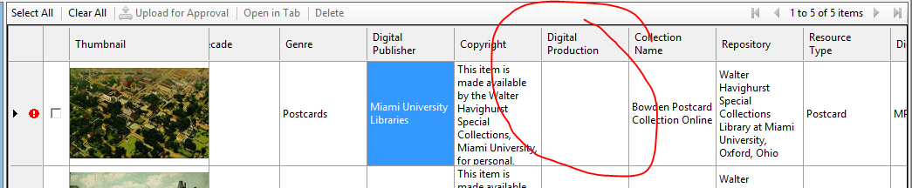
Afterwards, it should look like this:
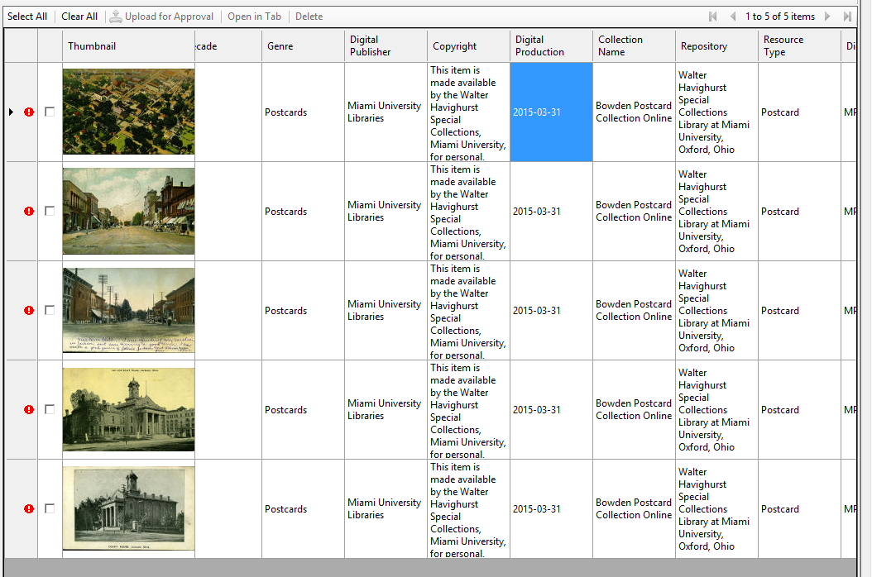

7) Next, I collapse the “Series” field, since it does not apply to most postcards. Marcus will let you know if you’re doing postcards in a series.
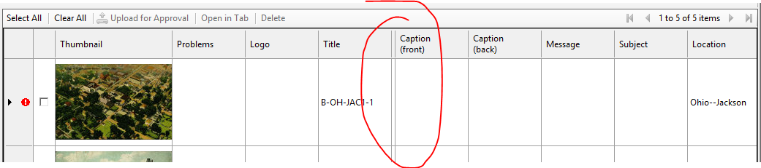
8) For each of the postcards in ContentDM, I edit the Title, Caption (front), and Caption (back) before any other fields. I fill these three fields for all the postcards, then move on to the Message, Date Postmarked, Postage, Recipient’s Name, and Recipient’s Address for all postcards. Then Subject for all postcards and Street Address for all postcards Then comes Photographer, Printer, Publisher, and Date Printed for all postcards. Lastly is Period for all postcards, and Decade for all postcards. Blocking the fields makes editing metadata go much quicker since you can correlate similarities between the fields.
Again, my process is thus:
- Block One
  - Title
  - Caption (Front)
  - Caption (Back)
- Block Two
  - Message
  - Date Postmarked
  - Postage
  - Recipient’s Name
  - Recipient’s Address
- Block Three
  - Subject
- Block Four
  - Street Address
- Block Five
  - Photographer
  - Printer
  - Publisher
  - Date Printed
- Block Six
  - Period
- Block Seven
  - Decade
Details of the metadata specifications can be found in the Metadata Guidelines on Google Drive. For Printers and Publishers, or if there are any distinguishing features, there are separate guides in Google Drive.

9) When you’ve finished with the metadata, double click on any field in a postcard to bring up the specifics for only that postcard. You should see this screen:
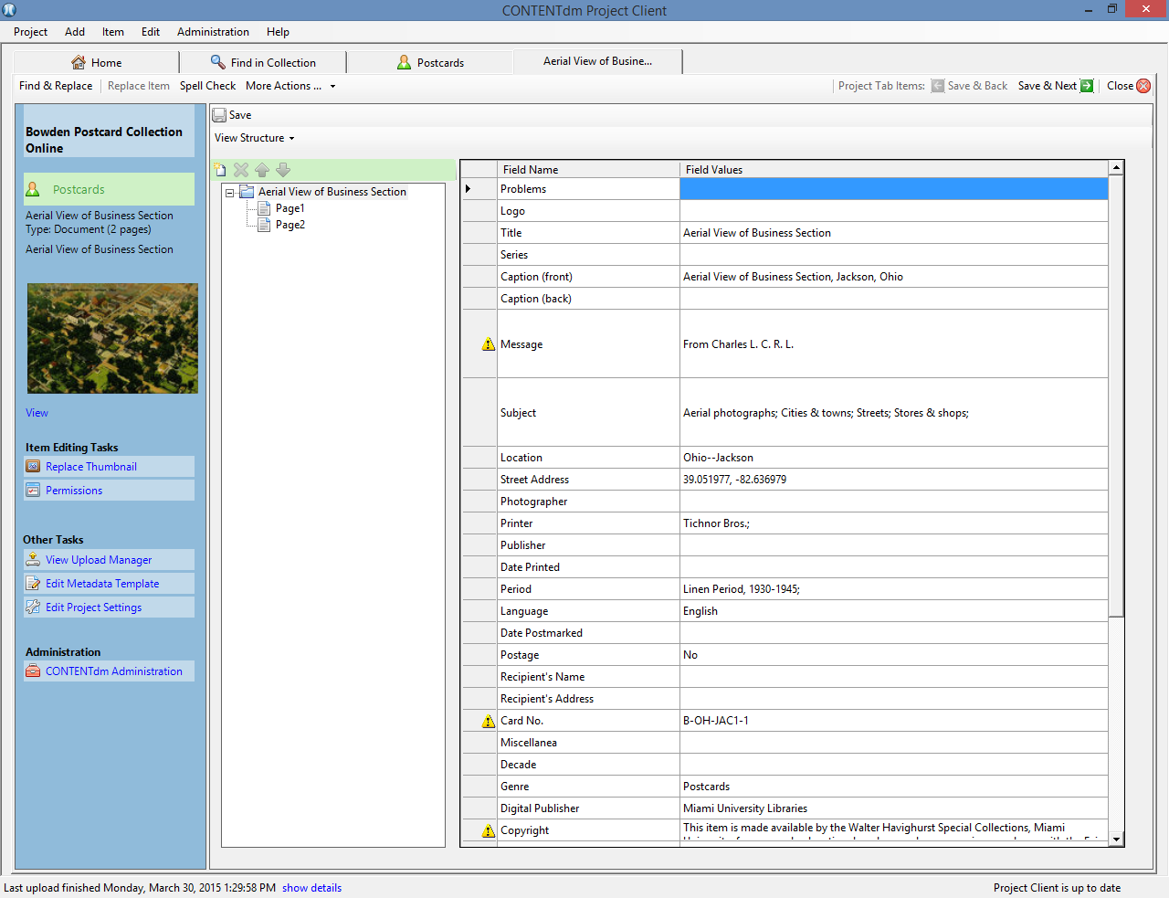
Double click on any of the fields with yellow exclamation points to check for spelling errors.
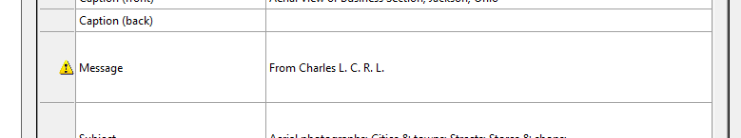

When double clicked, a dialogue box appears with spelling corrections:
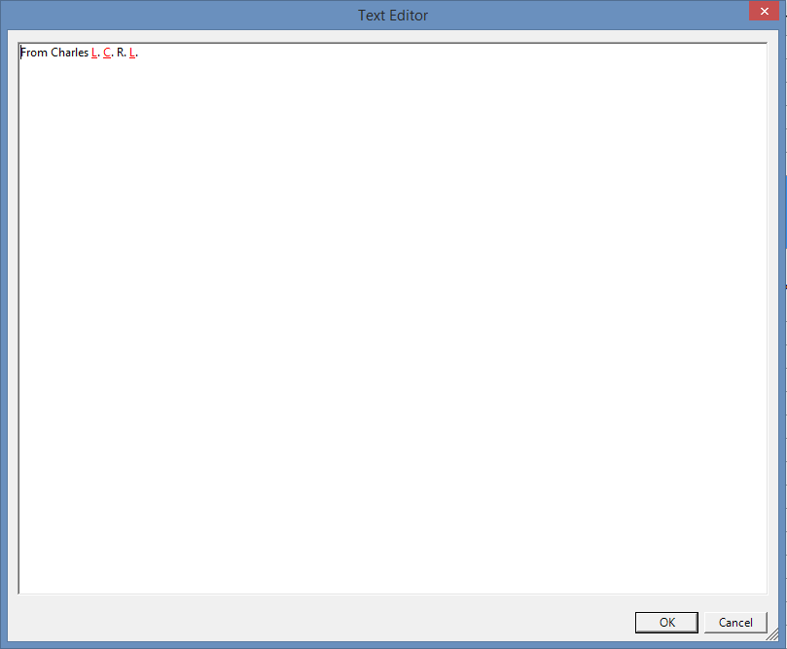
In this case, there are none, so I just press “OK.”
10) Check for errors in the scans by selecting the pages and making sure they match the postcard.
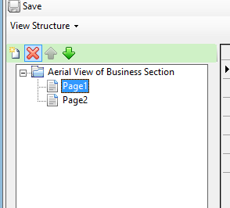
If there are errors in the scan, see Common Problems (5).

11) Because of the way ContentDM is set up, after quality-checking all of your finished postcards, it’s easier to completely exit the program and re-open it before trying to upload finished postcards. Do this. If there is the yellow or red exclamation point next to your finished postcard, see Common Problems (6) or (7). Otherwise, it should look like this:
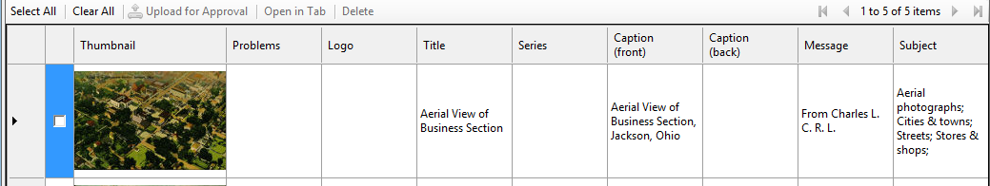
Check the box next to the image and click the “Upload for Approval” button:
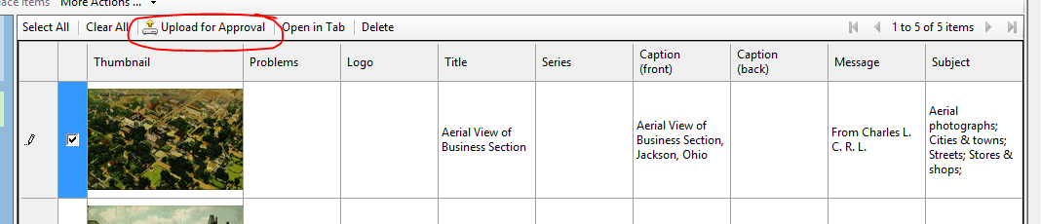
Upload progress can be seen in the bottom left corner of the screen or when the “Home” tab is selected. Do not exit ContentDM while there is an upload going- it will pause the upload and/or cause an error to appear (it’s not a big deal though- it sorts itself out when you reopen it).

Quick Starting Steps
1) Open ContentDM and “Postcards” tab.
2) Collapse fields between “Title” and “Card No.” Copy the serial number from the title field into the respective “Card No.” box.
3) Exit and re-open ContentDM.
4) Fill out “Location” for all postcards. If all postcards are from the same location, use the “Fill Down” option.
5) Fill the “Postage” field with the word “No” for all postcards.
6) Fill the “Digital Production” field with the current date in the format YYYY-MM-DD for all postcards.
7) Collapse the “Series” field.
8) Edit the Metadata in this order (at the completion of each block, all postcards should have those fields filled):
- Block One
  - Title
  - Caption (Front)
  - Caption (Back)
- Block Two
  - Message
  - Date Postmarked
  - Postage
  - Recipient’s Name
  - Recipient’s Address
- Block Three
  - Subject
- Block Four
  - Street Address
- Block Five
  - Photographer
  - Printer
  - Publisher
  - Date Printed
- Block Six
  - Period
- Block Seven
  - Decade

9) Check for spelling errors.
10) Check for errors with the scanned images. If there are errors in the scan, see Common Problems (5).
11) Check the box next to the image and click “Upload for Approval.” If there is a yellow or red exclamation point next to your finished postcard, see Common Problems (6) or (7).

Pro Tips and Shortcuts
- ContentDM automatically sorts postcards in the order you’ve added them, so, for example, if you added postcard 1, then 2, then 4, then 3, the order they will appear will be 1, 2, 4, 3.
- You can sort postcards by other fields by right-clicking on the field you’d like to sort them by. So, if you added postcards out of order, you can click the “Card No.” field (after adding the card numbers) and the order for the above example will be 1, 2, 3, 4. Empty fields will be either first or last, depending on the way you have a field sorted. To reset sorting back to the default, exit and re-open the program.
- There is no need to individually type information for each field if postcards are the same or very similar. Fields like “Subject” and “Street Address” can just be copied and pasted from one postcard to the next.
- Printers and Publishers are easily the most complicated and messy fields of metadata. If there any questions or anything needs clarified, you should ask Marcus.
- I like to have a separate Word document with the Periods and (common) Decades open when doing these two fields. You can collapse the fields you don’t need, make the window size smaller, and just copy and paste from the Word document to ContentDM. It makes things go a bit quicker, since you don’t need to open the individual postcards to get a new category.

Metadata Tips by Field
Disclaimer: Most of this information can be found in the Metadata Guidelines in Google Drive. It has more examples and more technical information and is an extremely useful resource that should not be ignored in favor of this. I have omitted fields that do not often get edited – information for those fields can be found in the Metadata Guidelines. And remember: as the postcard collection changes, so might some of these. Marcus always has final say and should be consulted with any issues.
Problems
- A place to mention any issues with the postcard. If it’s more than the message being in German, unreadable, or obvious damage to the postcard, you may want to also mention it to Marcus.
Logo
- If there is a logo on the postcard that isn’t in the guides, add it under the “Unknown Logos” portion of the Logos Guide and then mention the respective logo here. For more information on how to do this, see the “Using and Editing the Postcard Guides” section.
Title
- The title is usually a portion of the Caption (front or back).
- Avoid using the word “The” at the beginning of the title.
- Don’t put the location of the postcard here.
  - i. e. if the postcard caption says “Municipal Swimming Pool, Cincinnati, Ohio” a good title would be “Municipal Swimming Pool”
  - Exception: When the postcard says something similar to “Greetings from Cincinnati, Ohio,” the title would be “Greetings from Cincinnati.”
Series
- Most of the time a series will be pre-defined by Marcus. This field has a controlled vocabulary. If you think a postcard should be a part of a series (Such as the 1913 flood series), talk to Marcus about it.

Caption (Front)
- This is ALL the printed text on the front of the postcard, except any printer, publisher, and photographer names or copyright information.
- Be sure to write any serial number if one appears on the front of the postcard.
- This may be handwritten if the postcard is an old “real-photo” postcard. For more information on these, see Common Problems (8).
- So if all the text on the front of a postcard is “Municipal Swimming Pool, Cincinnati, Ohio Ohio River Scenic Views 3A4438 ©Curt Teich & Co. 1933” the caption would be “Municipal Swimming Pool, Cincinnati, Ohio Ohio River Scenic Views 3A4438.”
  - The other information would be filled out in other fields – Curt Teich & Co. is the Printer and 1933 is the Date Printed.
Caption (Back)
- This is any printed text on the back of the postcard that describes the image on the front.
- This does not include the serial number, printer, publisher, the word “Post Card,” text found in the stamp box, the “Write Message Here” and “Write Address Here” labels, etc. If you’re not sure if some typed text is a message or caption, see Common Problems (9).
- This is usually found on the upper left-hand side, generally above where a message would go.
Message
- This is any handwritten information on the card. It may be on the front, back, or both.
- Include the date, if there’s one written on the postcard.
- Try to type the message in the order it was written (otherwise it might not make sense).
- Do include the name of the sender, but not the address information.
- The collectors of the postcards occasionally wrote on the back of postcards- this is considered part of the message, but separate information.
  - If you find information written by Bowden, it would be in the format [Bowden--Message]. Bowden often added location notes to the backs for later sorting. He also bought postcards and later wrote information on the trip or historical information (family events, etc.) on them. For examples and identifying features about Bowden’s handwriting, see Common Problems (10).
  - If the information handwritten on the postcard is a price or number, it can be ignored.
Subject
- This is a description of the image on the front of the postcard.
- For help with the controlled vocabulary, see the Thesaurus for Graphic Materials section under “Useful Websites.”
- Don’t describe the message or the current condition of the location.
  - So if the image is of a lake that got drained in the 50’s and turned into a housing development, describe the lake, not the housing development.
Location
- This is the location of the postcard, as sorted by the collector.
- Occasionally you may need to add more than one location- if you believe the location is not correct or that you need multiple locations, discuss it with Marcus.
- If you need help determining the location, see Common Problems (4)

Street Address
- This is the physical location of the image on the postcard and should be in coordinates, if possible. If not, a street address will suffice.
- Coordinates can be found in Google Maps by right-clicking the building and selecting “What’s here?” They will appear in the top left corner of the screen and can be copied and pasted into the box.
Photographer
- This is the person or studio who took the picture. They occasionally doubled as the Publisher, in which case the person or company should be listed under both. It has a controlled vocabulary. For formatting a photographer’s name, see the Postcards Metadata Guidelines in Google Drive.
Printer
- The printer is the person or company who physically put the ink on the postcard, or printed it. There is always a printer, but they may not be credited on the postcard.
- Printers often doubled as a publisher, but only list them in the Printer field.
- If there is a logo on the postcard, check the Logos and Distinguishing Features guide in Google Drive to check the name and whether it belongs to the printer or publisher.
- The guides in Google Drive are searchable- printers often went by multiple names, so search the guides (CTRL+F) to see if the name you see is a printer, publisher, or other name.
- Often you’ll only see a printing process (examples include “Photochrome,” “Velva-tone,” “Sky-tint,” etc.) As many of these names as practical are listed in the guides, and can also be looked up by the style in the Logos and Distinguishing Features guide.
- If a name is followed by “Publisher,” it DOES NOT necessarily mean they are a publisher. The same is true when looking up a printer online. Other people don’t always define “Printer” and “Publisher” as we do – often they’ll list a printer as a publisher. This is similar to the way the maker of a book is considered a “publisher,” even though, for our purposes, we would consider them a “printer” because they physically created the book.
- There are several printers that put their initials in the stamp box – this can be frustrating if there is postage, so check the Logos Guide.
  - If a postcard is a “Real-Photo” postcard, the initials in the stamp box may be referring to the paper type, not the printer. See the Metropostcard section of the Useful Websites for more information on paper types and real-photo cards. You can also seek information under the Common Problems (8).
- Printers and Publishers are easily the most complicated and messy fields of metadata. If there any questions or anything needs clarified, you should ask Marcus.

Publisher
- The publisher is a person, company, or store that helped in creation of the postcard. This may mean (but isn’t limited to) ordering, distributing, or selling the postcard. The publisher always worked with another company, whether or not that company is listed on the postcard.
- There are, on rare occasion, multiple publishers. They should all be listed, with a semi-colon between names.
- If a name is followed by “Publisher,” it DOES NOT necessarily mean they are a publisher. The same is true when looking up a printer online. Other people don’t always define “Printer” and “Publisher” as we do – often they’ll list a printer as a publisher. This is similar to the way the maker of a book is considered a “publisher,” even though, for our purposes, we would consider them a “printer” because they physically created the book.
- If there is a logo on the postcard, check the Logos and Distinguishing Features guide in Google Drive to check the name and whether it belongs to the printer or publisher.
- The guides in Google Drive are searchable- printers often went by multiple names, so search the guides (CTRL+F) to see if the name you see is a printer, publisher, or other name.
- Printers and Publishers are easily the most complicated and messy fields of metadata. If there any questions or anything needs clarified, you should ask Marcus
Date Printed
- This is the date the postcard was originally printed. Most often, it will be listed as a copyright date or as part of the serial number.
  - Currently there are only two companies that can be dated by serial number: Curt Teich & Co. (see Google Drive) and Wayne Paper Box & Prtg. (See Useful Websites)
  - Some Curt Teich postcards may misrepresent the date they were printed due to reprinting. If the postcard does not match the date from the serial number (for example, it looks like a White Boarder period card, but the date is given as 1908), it’s probably an incorrect date and should be left blank.
  - Similarly, some of the publishers that worked with Curt Teich used a similar serial number format that, when analyzed, give an earlier date than it looks (the most notorious for this is I. Robbins & Son). In these cases, just leave the date blank.
- If the dates across multiple fields do not align, see Common Problems (11).
- If the postcard is a “Real Photo” postcard, do not use the paper type to obtain a date. This will likely misrepresent the age since postcards could be printed on old paper.
Period
- This is an estimated date range for when the postcard could have been printed. They’re based off of distinguishing features found across many postcards from certain times. For more information on using the controlled vocabulary dates, see the North Carolina Postcard Periods portion of Useful Websites.
- If the dates across multiple fields do not align, see Common Problems (11).
Date Postmarked
- This is the date from the postmark on the postcard. It should be in YYYY-MM-DD format.
- If the year or day is missing, just put the rest of the date.
- For a few years prior to WWI (about 1906 to 1912), the year is sometimes found to the bottom right, outside of the circle.
- When there are multiple postmarks, use the date from the earliest one (from where the postcard was sent).
- If the dates across multiple fields do not align, see Common Problems (11).
Postage
- There are only two options for this: Yes, there is a stamp, or No, there is not a stamp.
- Partial stamps count as a stamp.
- If a stamp has been removed, there is no postage.
Recipient’s Name
- This is the name of the person or company to which the postcard was sent, in the format Last Name, First Name.
- A “Care of” or “c/o” does not go in this field; it’s a part of the address.
- Do not use titles (Mr., Mrs., Dr., Rev., etc.)
  - Exceptions to this occur: when the addressee is only given an initial or her husband’s first name, but is given the title Mrs. So if the postcard says “Mrs. J. Coleman,” or “Mrs. John Coleman” the field should say “Coleman, J., Mrs.” or “Coleman, John, Mrs.” respectively. This is to alleviate confusion- at the time, some women went by their husband’s names, so we cannot distinguish between whether an initial belongs to her or her husband.
- If there are multiple recipients, list them with a semicolon between names.
  - If the addressees were “Mr. and Mrs. John Coleman” the field should say “Coleman, John; Coleman, John, Mrs.”
Recipient’s Address
- This is the address as it appears on the card, spelling errors and everything.
  - Often people shortened the name “Cincinnati” to “Cinty” or “Cinti.” Leave this abbreviation.
- If the postcard says “R. R.” or “R. F. D.” and a number, this needs to be included. This was for rural addresses.
- “Care of” or “c/o” goes in this field, not the recipient’s name.
  - For example, if the entire right side of the postcard says “John Coleman, c/o Mrs. John Coleman, Cinti, Ohio R. R. #1” the address is “c/o Mrs. John Coleman, Cinti, Ohio R. R. #1”
Miscellanea
- If an item is found with a postcard that is not a postcard (a newspaper clipping, photograph, etc.), this is where you should briefly describe it.
- If more than one postcard is found in the sleeve, see Common Problems (12).
- If you’re not certain whether or not an object is a postcard or miscellanea, ask Marcus.
Decade
- The decade from which the card was printed, if it’s known.
- You can use context clues from the Period and Date Postmarked fields to figure this out on occasion.
  - Be wary when using the Date Postmarked as a decade; oftentimes people sent postcards that were printed much earlier than they purchased or used. People could be sending a postcard that’s 10 years or older. This is especially true in the 1940’s and later, when people started postcard collections and sent postcards they had to other collectors. Bowden, one of the collectors, did this.
- In the Printer’s and Publisher’s guides on Google Drive, there are a few companies that only printed within a certain date range. This can also be used to find the decade, so be sure to check it.
- If the dates across multiple fields do not align, see Common Problems (11).

Useful Websites
- CardCow
  - http://www.cardcow.com/
  - I primarily only use this website when verifying whether a company or person is a printer or publisher. It’s a website that sells postcards, but if you look in the upper left corner, there is an advanced search option. Use this and type in the name of the company in the “Publisher” field, then search.
    - Looking mostly at the back of the postcards, a publisher will be working with another company- generally a known printer. A printer will often have postcard that don’t list other companies.
  - I have this bookmarked. I recommend doing the same.

- Metropostcard
  - http://www.metropostcard.com/
  - This is probably the most useful website for postcards I have found. There are many links describing processes and details about postcards.
    - For the printers and publishers list : http://www.metropostcard.com/metropcpublishers.html
      - Note: They do not clarify what determines a printer from a publisher- take this information with a grain of salt. Also, not all printers and publishers are on here.
      - This guide can be used to identify logos that we don’t necessarily have in the guide. However, it is not a comprehensive list and does not include all logos.
    - For information on Real Photo Postcards: http://www.metropostcard.com/guiderealphoto.html
      - If you scroll down, on the left hand side are different paper types, their initials, and any defining features. This can be used to tell if the information in a stamp box is for a printer, publisher, or paper type.
    - For other guides available: http://www.metropostcard.com/metropcguides.html
  - I have this website bookmarked. I recommend doing the same.

- North Carolina Postcard Periods
  - http://www2.lib.unc.edu/dc/nc_post/about.php
  - This gives the descriptions of the postcard periods.

- Old Ohio Schools
  - http://www.oldohioschools.com/
  - Super useful and sorted by the county, this lists old schools by city. Included are the locations (if available), an image (if possible), whether or not the building is still standing, and the date it was built.

- Thesaurus for Graphic Materials
  - http://www.loc.gov/pictures/collection/tgm/
  - This is extremely valuable resource when first learning the controlled vocabulary that ContentDM uses for the Subject. Search a word, and it will suggest words that are in the controlled vocabulary.

- Wayne Paper Box & Mfg. Dating Guide
  - http://www.dejean.com/salem/1930s/wayneboxcards_becker.html
  - Use this to date Wayne Paper Box & Mfg. postcards.

Using and Editing the Postcard Guides
Note: Please, please, please do not edit any documents (except the New Publishers and Printers document) in Google Drive. This messes up the formatting and can cause images to disappear. This is why there is a PDF version of the Logos Table- so the images always show up and we have a backup for if someone tries to edit it in Google Drive. Please download the documents, edit them in Microsoft Word, and upload the edited document back into Google Drive. Don’t forget to delete the old version of the document after you’ve made changes.
Dating Curt Teich Cards
- This document cannot be edited- it should be used as a reference for dating Curt Teich postcards only. Note that the dates given by dating Teich cards are not always accurate. Also note that Woolsworth postcards are Teich postcards and can be dated using the same methods.

Logos Table
- Use this document to identify printers and publishers by distinguishing features known to be associated with them.
- Paper types (see Common Problems (8) or the Metropostcard section of Useful Websites) are not listed in this guide- there are too many of them and the Metropostcard website has a very good list of them.
- Page 16 describes the difference between the Curt Teich and Tichnor Bros. logo that is extremely similar.
- Page 17 is where the Unknown Logos begin. This is the part that will be constantly changing with new information and where you should add a logo that you didn’t see in the guides and doesn’t have a known associated printer or publisher.
- To add a Logo that has a known Printer or Publisher:
  - Download the document from Google Drive.
  - Open the document in Microsoft Word.
  - Scroll to the location (alphabetically) where the Printer or Publisher should be located. These are sorted the way ContentDM sorts them, so J. A. and J. B. come before Ja.
  - Add the Printer or Publisher name to a new row in the document (if needed). Also type whether the company/person is a Printer or Publisher.
  - Use the digital file of the postcard (see page 2) to pull up an image of the postcard with the logo.
  - Use “Snipping Tool” (found by pressing the start button on the bottom left of your screen, then “All Programs,” then “Windows Accessories”) to make a copy of the logo.
  - Copy and paste the logo into the document.
  - Save and upload the document back into Google Docs.
  - Delete the old document and rename the new one to Logos Table.docx
  - If this is a new printer or publisher, be sure to add them to the New Printers and Publishers guide, and later the Printer Details or Publisher Details once they are verified and researched.
- To add a Unknown Logo:
  - Download the document from Google Drive.
  - Open the document in Microsoft Word.
  - Scroll to the bottom of the document
  - Add a new row to the bottom, if needed.
  - Enter a short description of the logo and the card number of the postcard.
  - Use the digital file of the postcard (see page 2) to pull up an image of the postcard with the logo.
  - Use “Snipping Tool” (found by pressing the start button on the bottom left of your screen, then “All Programs,” then “Windows Accessories”) to make a copy of the logo.
  - Copy and paste the logo into the document.
  - Save and upload the document back into Google Docs.
  - Delete the old document and rename the new one to Logos Table.docx

New Publishers and Printers
- Use this to add a new publisher or printer to the controlled vocabulary. So, for example, if you come across a postcard with a name that is not in the controlled vocabulary, type the name into the field you think it belongs in then type it (exactly how you see it on the postcard) in a new line at the bottom of this document.
  - This will cause a yellow error to appear next to the image of the postcard in ContentDM. That’s okay. It’s just reminding you that what you entered isn’t a part of the controlled vocabulary, but will still allow you to upload it. For more information, see Common Problems (6).
  - If a printer or publisher name begins with “The” or “A” on the postcard, ignore it when adding it to the collection. So “The Five and Dime Store” would be “Five and Dime Store.”
- If there is an associated printer with the publisher, you should list them as well. Add any other information you can as a comment.
- This document is the only one that should be edited in Google Drive. All others should be downloaded and edited in Microsoft Word.
- The purpose of this is to allow further research at later dates on the printers and publishers that are added to verify that they are, in fact, a printer or a publisher. After the research has been done, the new printer or publisher will be added to either the Printer Details or Publisher Details guide.
  - Once a name has been researched and added, it will be deleted.
  - If a name is highlighted in blue, that means it has been researched and added, but there are important comments attached to it. You should read these comments to keep up to date on the collection.

Printer Details
- This is a reference guide for information related to Printers. This information is gathered after extensive research inside and outside of our collection, but is constantly evolving. This means that there may be changes or errors as new information is gained.
- The last column, labeled “V” is whether or not the printer is verified – red means no, “Y” means yes. Verification means, in the simplest sense, that another postcard by this printer has been found outside of our collection. This is a means of indicating how secure and accurate the information regarding this printer might be.
- “Other Names” refer to names and processes used- anything that is unique to the printer that may help in identifying the company as a printer of the postcard.
  - For example, a Curt Teich card may go by “Curt Teich & Co,” the main company name, “C. T. American Art,” another name for the company, or “Commercialchrome,” a printing process.
  - Several printers may use the same name for a process, but the design of the back of the card will be unique for each printer.
- Editing should only be done after lots of research, but it can be edited in the same way as the Logos Table document. Add as complete of information as possible.
  - Only the main logo for the printer is added. Any large logos or distinguishing features should be added to the logos guide, but not to this one.

Publisher Details
- This is a reference guide for information related to Publishers. This information is gathered after extensive research inside and outside of our collection, but is constantly evolving. This means that there may be changes or errors as new information is gained.
- The “Associated Printer” is when the company uses one or very few printers; this is useful since oftentimes the printer can be narrowed down from this based on other distinguishing features.
  - Only the main printer logo is listed for each printer, and often no logo appears. Use the Logos Table document to help identify the printer.
- Editing should only be done after lots of research, but it can be edited in the same way as the Logos Table document and Printer Details document. Add as complete of information as possible.

Common Problems
1) There’s no digital copy of this postcard 33
2) This postcard has more than two images or sides 33
3) I added a postcard to be uploaded twice 34
4) How do I know the location of my postcard? 35
5) There’s a problem with the scanned images of my postcard 35-36
6) There’s a yellow exclamation point next to my postcard. 36
7) There’s a red exclamation point next to my postcard 36
8) This postcard is an old black-and-white photograph 37
9) Is this typed information part of a message or caption? 37
10) Bowden’s collection notes 37
11) When dates aren’t matching 38
12) Multiple postcards are in one sleeve 38

1) There’s no digital copy of this postcard.
- If you cannot find a digital copy of a postcard, it could be for a few reasons.
  - One: The postcard was scanned, but there’s a typo in the name of the digital file. Search for possible alternatives (like “O” instead of a zero).
  - Two: Marcus didn’t copy the digital file to the postcard folder. All postcard scans are saved in a separate location, and Marcus has to copy over the ones we need to upload. Occasionally one doesn’t copy, or if you’re doing a special project he may not have copied it. Check with him to see if he has a copy of it.
  - Three: The postcard wasn’t scanned by the company when we sent it out. You will need to manually scan the postcard (see 5).

2) This postcard has more than two images or sides.
- Step 1) Make sure all the images are in the digital file. If they are not, see 5. The first scan should be of the front of the outside of the folder. The last image should be the back of the outside of the folder. Make sure every part of the postcard is represented by an image, including the envelope lid. Check that images are rotated properly. For a good example of a postcard folder scan, see B-OH-DAY1-795 (you can search for this postcard on the collection website).
- Step 2) Upload the image into ContentDM. After clicking “Add,” on the first page of the pop-up screen, select “Monograph” instead of “Postcard.” Be sure that you change this back to “Postcard” for subsequent postcards.
- Step 3) Continue the upload as normal.
- Step 4) When editing the metadata, use the outside of the postcard (the folder part) for the main information, such as captions and messages.
- Step 5) If there are captions on images other than the outside, you can add this text by double clicking on the postcard to pull up all the metadata for that card, selecting the scan you want to edit on the side (like when you’re quality checking the postcard), and adding the information there. Only change the captions or messages in this section. Recipients should be on the main page.

3) I added a postcard twice.
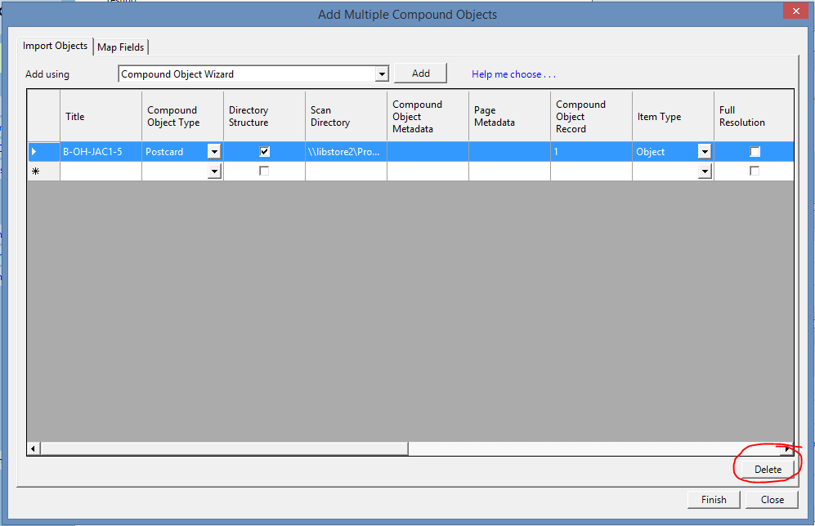
- If you have only completed through Step 14 (you haven’t uploaded them into ContentDM yet), click on box to the left of the duplicate postcard name to highlight the file, then press “Delete in the bottom right of the dialogue box.
- If you’ve already uploaded the postcard to ContentDM but haven’t submitted it for approval, select the check box next to the duplicate postcard, then press the “Delete” button. Be sure to check that it is actually a duplicate postcard, not just another postcard that looks exactly the same as the first. They should have separate card numbers, but you may have just mistyped the second one.
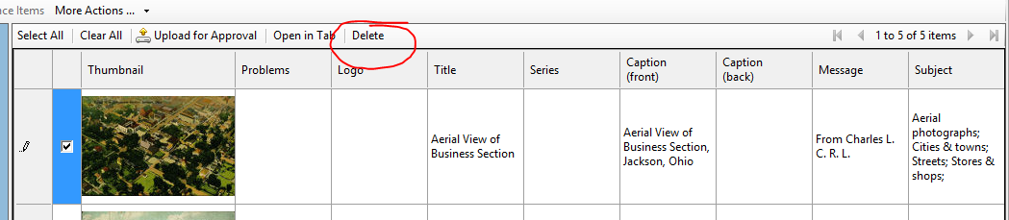
- If you have already submitted the duplicate postcard for approval (it no longer shows in ContentDM), tell Marcus as soon as you can and explain to him the problem.

4) How do I know the location of my postcard?
- Location can be a tricky field. The location is determined by how the collector originally sorted the postcards while they were a private collection. Usually this means they are sorted by the town name on the postcard, but that’s not always the case, especially for well-known parks.
  - For example, sometimes postcards for Hueston Woods are sorted as their own location, but also sorted as Oxford postcards. This means we have postcards of Hueston Woods with a location of “Ohio--Hueston Woods” and “Ohio--Oxford.”
- You can generally determine the location by checking the card number of the postcard. The first letter represents the collector’s name, the second two are either the state or country code, and the next three are the first three letters of the location (with a few exceptions, like for series – see the Metadata Guidelines document in Google Drive for more information) The card numbers were determined by the location given to us, either by the town name on the postcard or by the town name written on the postcard by the collector.
- The location isn’t always the same as the Street Address, which is why we list both. Hueston Woods isn’t actually in Oxford (it’s not even in the same county), but Oxford is the closest city which is why the postcard says Oxford.
- On occasion, there are postcards that should have two locations listed. This is usually the case when the location as the collector sorted it isn’t what was directly stated on the postcard, or if two locations are mentioned on the postcard, such as with B-OH-CAM1-44. This postcard was sorted into Cambridge, Ohio, but could just as easily been found in Wheeling, West Virginia.
- Rarely, there will be a postcard sorted into the completely wrong location. This was the case with B-MO-HER1-1, which was sorted into Bath, Ohio because the collector wasn’t sure where the actual location was. A case like this should be discussed with Marcus before any decisions are made about changing the location.

5) There’s a problem with the scanned images of my postcard.
- The best course of action when there’s an issue with a scanned image of a postcard is to delete the entire file out of ContentDM (see 3, bullet point 2) and fix the digital file. If you’ve already added all the metadata and were close to submitting the postcard for approval, wait until you’ve uploaded the correctly scanned file, copy and paste the information from the bad file into the good one, then delete the bad file.
- If a scan just needs rotated, open up the digital file, double click on the image that needs rotated to open Windows Photo Viewer, and click the “Rotate 90°” button, then exit and upload the postcard into ContentDM.
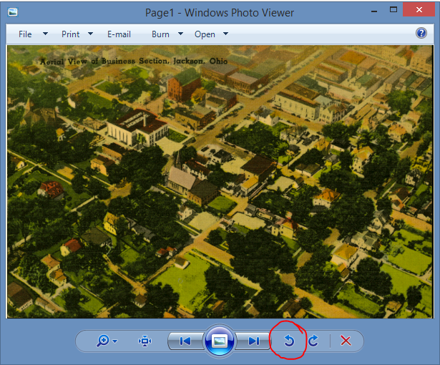
- If there are extra scans in the folder (this happens occasionally when the company scans post-it notes), you can simply delete the extra files from the digital file, then upload the postcard into ContentDM.
- If there are scans missing from the folder or the scan is just not a good representation of the postcard, you will have to use the scanner attached to the computer to manually add them. Instructions on how to do this can be found in the Postcards Workflow document in Google Drive. For more information or clarification on scanning postcards, talk to Marcus.
- Examples of poorly scanned postcards are when:
  - The physical and digital colors of the postcard are distinctly different (blues look green or something)
  - A portion of the postcard is cut off, like a scalloped edge is not seen on the digital image.
  - There is a large amount of background visible (usually appears as a white bar on the side of the image)
  - The scan is crooked.

6) There’s a yellow exclamation point next to my postcard.
- This is a warning from ContentDM that there is something wrong with the postcard, but it will still allow you to upload it, most commonly:
  - There is a spelling error in the corresponding field- either correct the spelling or ignore it (you should definitely ignore it if the word is spelled how it was spelled on the postcard)
  - You’ve added a word that isn’t in the controlled vocabulary.
- You can determine what the error is by hovering your cursor over the exclamation point.
  - If the tag says “not found in controlled vocabulary” but doesn’t say what isn’t found, that means there’s a space after a semi-colon somewhere in one of the controlled vocabulary fields, usually after the last word in the subject field.
- If you have added a word that isn’t in the controlled vocabulary:
  - If it’s in the Subject, Decade, Series, or Period field, change the word to something else. If you need help with the controlled vocabulary in the Series field, see the Thesaurus for Graphic Materials section of “Useful Websites.”
  - If it’s in the Photographer field, double check with the controlled vocabulary to see if the person or company might go by another name, and if they do not, ignore the error.
  - If it’s in the Printer or Publisher field, read through the Printers and Publishers sections of the “Metadata Tips by Field,” search through the Printers and Publishers guides on Google Docs, then, if needed, add the name to the “New Publishers and Printers” document on Google Drive, using the instructions given in the “Using and Editing the Postcard Guides” section.

7) There’s a red exclamation point next to my postcard.
- This is a warning from ContentDM that something is wrong with the postcard, and it’s not going to allow you to submit it for approval. This is most commonly caused by:
  - The program not registering that you’ve finished all the metadata yet.
  - You’ve clicked on the individual image files and it thinks you need to add the metadata for them (you do not; close and re-open ContentDM and the error will disappear).
  - A required field is not filled in yet.
- If you hover the cursor over the exclamation, it will tell you what the error is so you can fix it.
- Most often, if you’ve filled in all the metadata, you can exit the program and reopen it and the error will go away. If it does not and ContentDM is giving you issues, see if Marcus can fix the problem.

8) This postcard is an old black-and-white photograph.
- This is called a “Real Photo” postcard, and they can be a real pain to get information on. These tend to be printed locally by the photographer in small batches and have very little to no provenance information.
  - You’ll want to make sure that it’s meant to be a postcard and not just a photograph – if it’s not a postcard, there’s no text on the back (it doesn’t look like a postcard back)
- The best resource for real photo postcards is on Metropostcard (see the “Useful Websites” section). There is a description of the different paper types used.
- Some printers had “Real Photo” varieties, especially more recently, during the Photochrome Period. These are not to be confused with real photo postcards.
- The paper type of the postcard is never used as the printer or publisher, nor is it used for dating purposes. This is because the paper type date is generally a significant amount of time earlier than the image was actually printed.
- To get a date estimate, the best option is to look at dateable items in the image. Good examples include cars and clothing (I recommend brushing up on your knowledge of 1920’s, 30’s, and 40’s clothes and vehicles).
  - This dating technique should only be applied to real photo postcards. Printers and publishers often reprinted old images on new cards, whereas real photos were usually only printed close to when the photograph was taken.
9) Is this typed information part of a message or caption?
- Every so often, you’ll come across a postcard with typed information that was added after the postcard was printed. This is almost always a message. The only exception is when the typed information is directly related to the image on the postcard, such as a description of the building or town.
- If the information appears on the front (not in the “message” section of the postcard), it is generally considered a caption. Postcards with business or event information on the front were generally ordered in small batches, but information added to the back was usually added post-printing.
- Commonly seen typed information that is considered a message includes:
  - A typed (as opposed to handwritten) message that is extremely formal
  - Business or event information
10) Bowden’s collection notes
- One of the collectors, Clyde Bowden, is notorious for writing notes on the back of postcards. These notes are most often a location indicator and found in the upper left of the postcard, on the back. On occasion, they are longer notes, describing biographical events. Other collectors did this as well.
- These notes may be on postcards that have other messages, and are separate from one another. List Bowden’s notes (in brackets) first, then any other message as normal.
- Bowden’s handwriting is very distinct. You’ll soon be able to easily distinguish it from any other. For examples of Bowden’s handwriting, see
  - B-OH-OXF1-173
  - B-OH-OXF1-156
  - B-OH-OXF1-133
- If you come across a note written by Bowden (or any other collector), add the note to the message section as [Collector’s name-- Note]. So for a location given by Bowden as “Oxford, Ohio,” the message section would say [Bowden--Oxford, Ohio]. The three examples given above should serve as a guide for how a message should be approached.

11) When dates aren’t matching…
- In the postcard collection, we have four separate date categories that are used (Date Printed, Date Postmarked, Period, and Decade). All of them serve a different purpose and about half the time, they won’t align properly or clearly. There are several reasons this occurs, including (most commonly):
  - (Period and Date Printed) The card was printed using a technique that wasn’t popular at the time.
  - (Period and Date Printed) The card’s date printed is not accurate - there are several publishers that have similar-looking serial numbers to those of Curt Teich, but don’t represent the same time.
  - (Date Postmarked and Date Printed/Period) The postcard was sent far later than it was printed. This happened fairly often, especially once people started collecting postcards and exchanging them with each other. I regularly see postcards from the 1920’s that were sent in the 1940’s. Bowden, who donated the largest collection, even did this.
- The most important of data should be used to determine the rest. Therefore, the best hierarchy of importance I can give you is thus (from most important/accurate to least):
  - Date Printed, when it says it on the card (as a copyright, generally)
  - Decade, when obtained from Printer or Publisher guides
  - Date Printed, from serial number (with the exception of a few Publishers)
  - Date Postmarked, when corresponding with Date Printed or Period
  - Period
  - Date Postmarked, when not corresponding with Date Printed or Period
  - Decade
- This means that, if you have the date printed, the decade should and period should adapt to the date printed, even though it might not seem right.
  - For example, if the postcard has a copyright that says 1906, but it has a white border, you should still list the period as “Divided Back” or “Postcard Period” (depending on those characteristics) and the decade as “1900-1909.”
- An exception to this dating method occurs with real photo postcards. See (8) for more information on real photo cards.
12) Multiple postcards are in one sleeve.
- Whoops. This was probably a “my bad” situation. It happens. If you come across two (or more) postcards in one plastic sleeve, the first thing to do is to NOT IGNORE IT. Next, you should check the digital file for the postcard to see a) which postcard was scanned and b) that the scans are correct. Unless one of the postcards should have multiple images, it should be a standard file, with one postcard front and the corresponding back.
- Generally the first postcard, or the one in the front, is the one that was scanned. Use the original file name and card number to represent this card. The second card will need to be added to the collection manually.
- The new card should be added to the end of the cards from that location, so the new card number should be one higher than the last card number. You can then print out a label for the card and manually scan it. For more information on this, see the Metadata Guidelines in Google Drive.

Beginner’s Guidelines created by Meghan Pratschler for the Bowden Postcard Collection Online project
Walter Havighurst Special Collections, Miami University
Last Edited: 2015-04-06

