Printer | Other Names | Logo(s) | Notes | V
A. C. Bosselman & Co. |  |  | Red text on front and “Printed in Germany” appears on most of their cards, even when the name and logo do not (i. e. if it looks like it’s an AC and it’s also an Alexander….) | Y
A. H. Dean
A. M. Simon | A. M. S. | 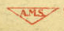 |  | Y
A. Q. Southwick |  |  |  | Y
Acmegraph Co. |  | 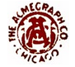 |  | Y
Ark Co.
Akron Postcard Co. |  | 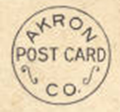 |  | Y
Albertype Co. |  |  |  | Y
American Floor Surfacing Machine Co.
American Import Co. |  |  |  | Y
American News Company | Americhrome  Lithochrome  Mezzochrome  Newvochrome  Octochrome (not to be confused with the Commerical Colortype Octochrome)  Photochrome (not to be confused with other Photochromes, such as those by Teich) | 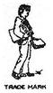 | Logo varies with type. Will usually have clover and/or initials. Also, ANC is notorious for using their own publishers/ distributors. For more information, ANC is found on the bottom of the “A” page in the publisher list on Metropostcard.com. | Y
American Oil Company |  | 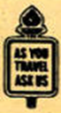 |  | Y
American Printing and Supply Co. |  | 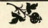 | Generally have intricate boarders around the photo. | Y
Anglo-American Publishing Co. | Anglo-American P. C. |  | Either black and white, or half-tone with red text. All cards printed before 1909. | Y
Art Manufacturing Co. | Art Mfg. Co. | 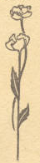 | Both the Amelia and Zanesville Companies are the same. All postcards date between 1908 and 1915. | Y
Arthur Jaffe Heliochrome Co.
Arthur McGraw
Artino Post Card Co. |  | 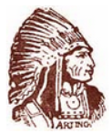 |  | Y
Artvue Post Card Co. |  |  |  | Y
Asheville Post Card Co. |  |  |  | Y
Atkinson News Co. |  |  |  | Y
Atlas Society |  |  | All postcards made between 1904-1909 | Y
Auburn Post Card Manufacturing Co. | Auburn Greeting Card Co. | 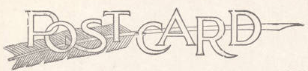 |  | Y
Axel Bahnsen
B. S. Reynolds Co | Foster & Reynolds |  |  | Y
Blaisdell Kull
Ballard Photo |  |  |  | Y
Bartone |  |  |  | Y
Batavia Post Card |  |  |  | Y
Black Hills Novelty Co. |  |  |  | Y
Bob Wyer Photo Cards |  |  | Photochrome period. Not to be confused with Henry S. Wyer cards, which are pre-1920. | Y
Book Mark Co. | The Book Mark Co. |  | Intricate “Post Card” details. | Y
Boutelle Mfr. | J. G. Boutelle;  Boutelle |  | Later postcards were printed by Teich. Only list as publisher if another printer is listed. | Y
Burlington Route |  |  |  | Y
Buswell’s Bookstore |  |  |  | Y
C. E. Wheelock and Co. |  | 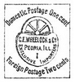 |  | Y
C. L. Taylor
C. P. Johnston Co. |  |  |  | Y
C. U. Williams | Brownette;  Photoette | 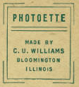 |  | Y
Cann’s Studio | Cann’s |  |  | Y
Capitol Souvenir Company |  |  |  | Y
Cardinell-Vincent Co. |  | 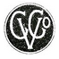 |  | Y
Champlin Press |  |  |  | Y
Chilton Company
Chisholm News Agency | Chisolm Bros. |  |  | Y
Chuck’s Color Fotos |  |  |  | Y
Clark Engraving and Printing Co. |  |  |  | Y
Clinton Company |  |  |  | Y
Collotype Co. |  |  |  | Y
Colonial Badge Co.
Colorart |  | 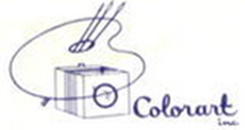 |  | Y
Colorcraft Studios
Colourpicture Pub. | Plastichrome  Colour Picture Pub. |  |  | Y
Consolidated Art Co. |  |  |  | Y
Commercial Colortype Co. | Octochrome; Commercialchrome;  Black & White;  Sky-Tint; | 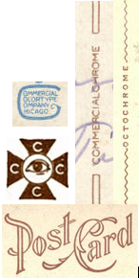 | Not to be confused with other varieties of Commercialchrome and Octochrome | Y
Craftsman Press |  |  |  | Y
Crescent Printing Co.
Crystal Cathedral Ministries
Curhan Co.
Curt Teich & Co. | C. T. Photochrom  C. T. American Art  C. T. Aquarelle  C. T. Artchrom  C. T. Colortone  Curtteichcolor  C. T. Photo-Platin |  | Half of all cards you look at will be some variation of Teich. Also, they can be dated by serial number. Do not list the date from the serial number if the publisher is I. Robbins & Son or H. H. Hamm; these are generally inaccurate dates. | Y
David S. Ireland
Decorator Art & Prints
Detroit Publishing Co. | Detroit Photochrom  Detroit Photographic  Detroit Phostint |  |  | Y
Dexter Press | Thomas Dexter Press  Dextone |  |  | Y
Dr. Trenkler & Co.
Dukane Press |  | 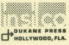 |  | Y
Dynacolor Graphics |  | 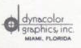 |  | Y
E. C. Kropp Co. |  |  | Initials are usually in the stamp box. May resemble Teich. | Y
Eagle Post Card View Co. | Blue Sky | 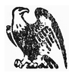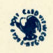 |  | Y
Eastern Illustrating Co. |  | 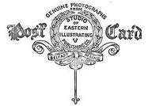 | May be printer (earlier) or publisher (1940’s and ‘50’s). | Y
Embetone
Edmiston Book & Sta. Co.
Edward H. Mitchell |  |  |  | Y
Emile Chmelitzki | Emil Chmelitzki  Chemlitzki |  |  | Y
Emil Pinkau & Co. |  |  | Printed cards for Illust. Post Card Co until 1909. | Y
Emma Bischoff Johnson
Eric Bruce |  |  | Printed in the 1980s | Y
F. Boellinger
Far West Studios |  |  |  | Y
Fincard
Fitzpatrick’s Printery
Francis A. Rugg | Frank A. Rugg  E. H. & F. A. Rugg |  |  | Y
Frank W. Swallow Post Card Co |  | 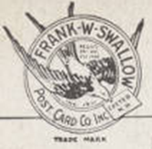 |  | Y
Franz Huld |  | 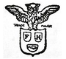 | Pre-1914 | Y
Gale Photo Card Co.
Gardner-Thompson Co. |  |  |  | Y
Garrison Color Corp. |  | 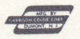 |  | Y
General Graphics Co.
Geo. H. Bowman Company | George H. Bowman |  |  | Y
George W. Etoll
Georgia Federation of Women’s Clubs
Gilbert Post Card Co. |  |  |  | Y
Globe Card Co.
Gorny-Winzeler Press |  |  |  | Y
Grafton Printing
Graphic Arts Co. | Graphic Arts Photo Service;  Krom-A-Tone;  Hamilton Printing Co. |  | If it’s a questionable but similar name, the printer’s location is always Hamilton, Ohio | Y
Graphic Facts of America |  |  |  | Y
Graycraft Card Co. |  |  |  | Y
Grogan Photo Service | Grogan Photo Co.;  Groganized;  Genuine Photograph Groganized;  Grogan Photo System |  |  | Y
H. A. Bingamon |  |  |  | Y
H. G. Zimmerman & Co. | Zim; Zimochrome |  |  | Y
H. H. Hamm | Harry H. Hamm | 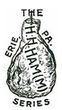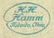 | May be either Toledo or Erie. Ham logo (top) is only found on postcards printed by H. H. Hamm. Logo on bottom is found on later postcards, printed by Teich or Commercial Colortype Company (who often aren’t named.) Only list as printer if ham logo is on the postcard. | Y
H. H. Tammen Curio Co. | H. H. T. Co. | 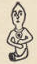 |  | Y
H. K. Barnett
H. L. Woehler |  | 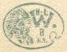 |  | Y
H. S. Crocker Co. | S. Crocker |  |  | Y
Hammer Graphics
Harrison Printing & Advertising Co. |  | 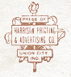 |  | Y
Hart Schaffner & Marx |  |  |  | Y
Hawaii and South Seas Curio Co. |  | 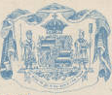 |  | Y
Henry S. Wyer | Wyer Art Store |  | Pre- 1920. Not to be confused with Bob Wyer cards, which are from the Photochrome Period. | Y
Herald House
Hermann Souvenir Post Card Co. |  |  | This is the company based in Missouri, not Chicago | Y
Hickory Hill Folks | Chromcast;  Colorcast |  |  | Y
Holmes, Tolle & Evans
Houston Art Print
Howard Glaser
Hugh C. Leighton Co. |  |  | All cards are from 1906-1909. | Y
Huston Eng. Co. | Huston Engraving Co.? |  |  | Y
Ignatz Stern |  |  |  | Y
Illustrated Post Card Co. | Illustrated Postal Card Co.  Illust. Post Card Co. (May look like LLUST) | 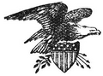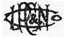 |  | Y
Imprimeries Réunies de Nancy | Impr. Réunies de Nancy | 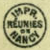 |  | Y
J. Bouton & Co. |  | 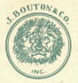 |  | Y
J. Murray Jordan |  | 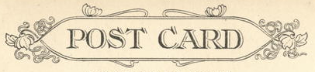 | Backplate always has the same design around the word “postcard” | Y
James J. Gillick & Co.
JAS |  |  |  | Y
Jenkins Enterprises |  |  |  | Y
John Hinde Curtteich |  |  |  | Y
John Hinde Limited |  | 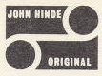 |  | Y
John Webb
Jos. Betz Printing Co.
Kaeser & Blair | Pictocards |  |  | Y
Kansas Industrial Development Commission |  |  |  | Y
Kawin & Co. |  |  |  | Y
Koelling and Klappenback |  |  |  | Y
Kolorview Press |  |  |  | Y
Koppel Color Cards |  |  |  | Y
Kraemer Art Co. |  | 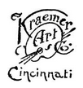 |  | Y
Kraus Mfg. Co. | Kraus Manufacturing Co. |  | 1912-1930 | Y
L. C. Overpeck | May look like I. C. Overpeck or Overpick
L. L. Cook Co. |  |  |  | Y
L. R. Brock Creative Services
La Cigogne
Lahke | Lahke Ptg. & Pub. Co.;  Lahke Bros.
Laurel Press |  | 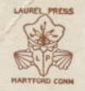 |  | Y
Le France Color Fotos |  |  |  | Y
Leighton & Valentine Co. |  | 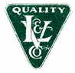 | All cards are from 1910 to 1914. | Y
Leiter Post Card Co. |  |  |  | Y
Lucky Prints |  |  |  | Y
Lumitone Photoprint |  |  |  | Y
M. Rieder |  |  | All cards are from 1901-1915. | Y
Marylee Esterle
Max Ettlinger & Co. | E. & M. Co.; E. M. Co.; M. & E. Co.; M. E. Co.; The Royal Series | 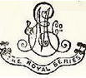 | All cards are from 1901-1916. | Y
Mayrose Co. |  |  |  | Y
McElroy & Buck
McGrew Color Graphics |  | 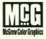 |  | Y
Meiser & Meiser |  |  |  | Y
Mercer Color
Meriden Gravure Co. |  |  |  | Y
Merrimack Post Card Co.
Messenger Press
Metrocraft | Metropolitan |  | Be careful not to confuse with below. | Y
Metropolitan News Co. |  |  | What I said above. | Y
Middaugh Printers
Midwest Book Company
Midwest Map Co. | MWM |  |  | Y
Mike Roberts Studio | Mike Roberts Color Productions;  Wesco;  Spectratone;  Scenic Art, Inc. (post 1995) | 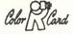 | Early work as a photographer, then printer, and finally publisher. Various Logos | Y
Miller Art Co. |  |  | Look similar to early Teichs. Do not confuse. | Y
Modern Postcard
Museum at Lower Shaker Village
MWM Dexter |  |  | Merger of MWM and Dexter. | Y
N. E. Paper & Stationery Co. |  |  |  | Y
N. N. |  | 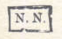
National Colortype Co. | Nat. or Natl., may have Cin at the end |  |  | Y
National Press |  |  |  | Y
Natural Color Company |  |  |  | Y
Nevada Post Card Co.
Newark Post Card Co.
New York-Dayton Photo Art
Northwest Orient Airlines Photo | Northwest Airlines |  |  | Y
Nu-Vista Prints |  |  |  | Y
Ohio Department of Natural Resources
Ohio Printing Company |  |  |  | Y
Ohio State Archaeological & Historical Society
Oxford Art Syndicate
Oxford Museum Association
Oxford Printing Co.
Pacific Novelty Co. |  | 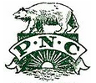 |  | Y
Paul C. Koeber Co. | PCK |  |  | Y
Paulding Postcard Co.
Perry Printing Co.
Philadelphia Post Card Co. | Phila. Post Card Co. | 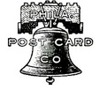 |  | Y
Photo & Souvenir Store
Photo View
Printing Service Co.
Process Color Scenes |  |  |  | Y
Quicksilver Photography
R. W. Griffing |  |  |  | Y
Raphael Tuck & Sons |  | 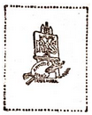 |  | Y
Richardson Printing Corp.
Robbins Bros Co. |  |  |  | Y
Roller Printing and Paper Co. |  |  |  | Y
Rosary Press
Roscoe Dixon
Rotograph Co. | Sol Art Prints |  |  | Y
Sarge Marsh
Samuel Langdorf & Co. | S. Langdorf  Langdorf | 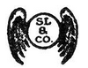 | May look like Rotograph card. | Y
San Antonio Card Co. |  |  |  | Y
Sanborn Souvenir Co. |  |  |  | Y
Santway Photo-Craft Co. | May look like “Photo-Crayt.” Other names include Velva Tone, Photo-Color, and Photo-Gloss |  |  | Y
School Post Card Co.
Security Lithograph Co. | Selithco | 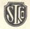 |  | Y
Snyder Mfg. Co. | F. W. Snyder;  Snyder’s Art & Gift Shop;  Frank W. Snyder |  | Frank Snyder was a local Oxford photographer. He is sometimes the printer, but often the publisher. List as printer if no other printer is known. | Y
Sohio
Southern Hotel
Souvenir Post Card Co. | E. Frey |  |  | Y
Stanwood-Hillson Co.
St. Louis Color Postcard Co. | St. Louis Postcard Co. | 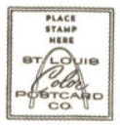 |  | Y
Sterling Printing Co. |  |  |  | Y
Straw Bros.
Sturgis Lithograph Co.
Suhling & Koehn Co. | Suhling Co. |  |  | Y
Taylor & Son
Taylor, Platt & Co. | T. P. & Co. | 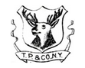 |  | Y
Taylor Art Co.
Tecraft Company |  |  |  | Y
Texas Department of Commerce
Thayer Publishing Co. |  | 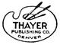 |  | Y
Thomas & Co. |  |  |  | Y
Tichnor Bros. |  |  | The difference between Tichnor and Teich when looking at fancy font: Teich says “made in Germany” | Y
Tolle & Evans Holmes
Tom Jones |  |  |  | Y
Trademark Concepts
Troy Historical Society
Union Oil Company | Truepicture |  |  | Y
Valentine & Sons Publishing Co. | Valentine’s Co. Ltd. Ltd.  Valentine’s  Valentine Publishing Co. |  |  | Y
Valentine-Souvenir Co. |  | 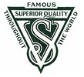 |  | Y
Verlagsanstalt
Victory Postcards
Vinton Printing Co.
W. A. Fisher Co. |  |  |  | Y
W. G. MacFarlane |  |  | Before 1908. | Y
W. H. Bowron
W. H. Case |  |  |  | Y
W. P. Jefferies Co.
W. W. Hixson & Co. |  | 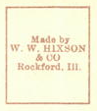 | Has distinctive slanting text on front and name appears in stamp box. | Y
Wayne Paper Box & Prtg. | Fort Wayne Printing;  Wayne Printing;  Wm. A. Didier |  | Can be Dated by serial number. See Useful Websites (or Google) | Y
Waynesville Historical Society
Weixelbaum | M. Weixelbaum Co. |  | Also a publisher; list as printer unless another is on the card. | Y
White House Publishing Co. |  |  |  | Y
Whitten & Dennison Post Card Co. |  |  |  | Y
Willens & Co.
Will P. Canaan Co. |  |  |  | Y
Wilson Card & Printing Agency
Woodgifts |  |  |  | Y
Woolsey & Blaser
Wyco Colour Productions |  |  |  | Y
Ye Postte Cardde Shoppe |  |  |  | Y
Yorkolor Process |  |  |  | Y

